PROJECT TITLE: CONDOR MS
DOC. NAME: Prime Item Development Specification (PIDS) for PSU

DOC. NO.: 5495-6000-00PS
REVISION: --
DATE: January 2024

RECORD OF REVISIONS
Rev |  | Issue Date |  | Revision Description
-- |  | January 2024 |  | First Release

List of TBDs
Reference | Description
3.2.10.5 | Temperature hysteresis limits – to be defined by manufacturer.
‎3.9.1.1 | Power up time in seconds – to be defined by manufacturer.

List of TBRs
Reference | Description
3.2.10.2.2 | Output over voltage protection - PSU turn-on waiting time period & Detection response times
‎3.2.10.4 | 3-phase fuse values
‎3.3.1 | PSU weight
‎3.7.2 | The PSU MTBF

List of TBCs
Reference | Description
3.2.10.2.2 | 115VAC Over Voltage Trip Point and Detection response time.

Table of Contents

1 SCOPE 8
1.1 Identification 8
1.2 Item Overview 8
1.3 Document overview 9
1.4 Abbreviations and Acronyms 10
1.5 Glossary 12
2 Referenced Documents 13
2.1 Elbit Systems Documents 13
2.2 Military Standards 13
2.3 Military Specifications 14
2.4 Military Handbook 14
2.5 Others 14
3 Requirements 16
3.1 Functional and Performance 16
3.1.1 PSU Main Functionality 16
3.1.2 Logic Statuses 16
3.1.3 Communication Interface 17
3.1.4 Log File Functionality 18
3.1.5 ON/OFF Functionality 19
3.1.5.1 System Reset (“short” reset) 20
3.1.5.2 System Power Off 21
3.1.6 Lamp indication 22
3.1.7 Sampled voltage outputs 23
3.1.8 PSU Built In Tests (BIT) 23
3.1.9 Resource Utilization 24
3.1.10 Functionality during Input Voltage Fault Conditions 24
3.2 Electrical Characteristics 25
3.2.1 Primary Input Power 25
3.2.1.1 28VDC Input 25
3.2.1.2 115VAC Input 25
3.2.1.3 Operation with Neutral 25
3.2.2 Power Consumption 25
3.2.3 Inrush Current 25
3.2.4 Output Power Characteristics 26
3.2.4.1 Peak power consumption profile 29
3.2.5 Efficiency 30
3.2.6 Power factor correction 30
3.2.7 Resistance 30
3.2.8 Isolation 30
3.2.9 Settling Time 32
3.2.10 Protections 32
3.2.10.1 Over-Current Protection 33
3.2.10.2 Over-Voltage Protection 33
3.2.10.2.1 Input over voltage protection 33
3.2.10.2.2 Output over voltage protection 33
3.2.10.3 Under-Voltage Protection 34
3.2.10.4 Input Fuses / Circuit Breakers 35
3.2.10.5 Over-Temperature Protection 35
3.2.10.6 Reverse-Voltage Protection 35
3.2.10.7 Missing-Phase Protection 35
3.3 Physical Characteristics 36
3.3.1 Weight 36
3.3.2 Dimensions 36
3.3.3 Color 36
3.4 External Interface 37
3.4.1 AIRCRAFT - PSU Interface 38
3.4.2 PSU-MIU Interface 38
3.4.3 PSU-Test Panel Interface 39
3.4.4 PSU-INS Interface 39
3.4.5 PSU-Camera Interface 39
3.4.6 PSU-ADLS Interface 40
3.4.7 PSU-EDU Interface 40
3.4.8 PSU-SPARE Interface (FFI) 40
3.4.9 PSU-TCU Interface 40
3.4.10 Plug & Play interface for a Testing Equipment 41
3.4.11 Mechanical/Thermal Interface 41
3.4.11.1 Thermal Interface 41
3.4.11.2 Mechanical Interface 41
3.5 Internal Interface 42
3.6 Safety 42
3.6.1 Capacitor Discharge 42
3.7 Reliability 42
3.7.1 Reliability Prediction 42
3.7.2 Specified MTBF 43
3.7.3 Service Life 43
3.7.4 Operational Reliability 43
3.8 Maintainability 44
3.8.1 Maintenance Design Guide Lines 44
3.8.2 Test Points and Test Connectors 45
3.8.3 Serial Number Indication 45
3.8.4 Elapsed Time Indication (ETI) 45
3.8.5 Elapsed Time Meter (ETM) 46
3.8.6 Software/firmware upload 46
3.9 Testability 47
3.9.1 Built In Test 47
3.9.1.1 Power Up BIT – performed upon startup 47
3.9.1.2 Periodic BIT – performed periodic 47
3.9.2 Interface to a Testing Equipment 47
3.9.3 Version Control of Programmable Components 47
3.10 Environmental Requirements 48
3.10.1 Temperature Altitude 48
3.10.2 Normal continuous operation 48
3.10.3 Intermittent operation 49
3.10.4 Non operating 49
3.10.5 Humidity 49
3.10.6 Explosive atmosphere 49
3.10.7 Acoustic Noise 49
3.10.8 Shock 49
3.10.9 Sand and dust 50
3.10.10 Fungus 50
3.10.11 Salt atmosphere 50
3.10.12 Acceleration 50
3.10.13 Vibration 51
3.10.13.1 Normal continuous operation 52
3.10.13.2 Endurance 55
3.11 Transportability and Storage 58
3.11.1 Transportability 58
3.11.2 Storage 58
3.12 Design and Construction 59
3.12.1 Selection of materials, processes and parts 59
3.12.2 Passive devices 59
3.12.3 Sealing and insulation materials 59
3.12.4 Treatment and finishing 60
3.12.5 Junction temperature 60
3.12.6 Printed Circuit Boards (PCBs) 60
3.12.7 Electromagnetic compatibility 61
3.12.8 EMC Requirements 61
3.12.9 Description of Requirements 61
3.12.10 Bonding 62
3.12.11 Grounding 62
3.12.11.1 Grounding concept 63
3.12.12 Shielding 63
3.12.13 External Cables 63
3.12.14 Other EMC recommended instructions: 64
3.12.15 Nameplate and Product Marking 65
3.12.16 Workmanship 65
3.12.17 Interchangeability 65
3.13 Human Performance / Human Engineering 66
3.14 Precedence and Criticality of Requirements Precedence 66
3.14.1 Key Characteristics and Critical Items 66
3.14.2 Precedence and Criticality of Requirements 66
4 Quality Assurance Provisions 67
4.1 Classification of Inspections 67
4.1.1 ESS – Environmental Stress Screening 67
4.1.2 Design Verification 67
4.1.3 ATP – Acceptance Test 67
4.2 Verification Cross-Reference Matrix - VCRM 68
4.3 Quality Conformance Inspection/Verification 72
4.3.1 Acceptance Tests 72
4.3.2 General 72
4.3.3 Examination of Product 72
4.3.4 Functional Tests 72
4.3.5 Rejection and Retest, 72
4.3.6 Environmental Verification Tests (EVT) 72
4.3.7 Environmental Stress Screening (ESS) 73
4.3.8 Random Vibration Test 74
4.3.9 Thermal Cycling Test 75
5 Requirements Traceability 77
6 Preparation for Delivery 78

List of Figures

Figure ‎1-1- PSU Overview 8
Figure ‎3-1- Reset Sequence Timing 20
Figure ‎3-2- Power-Off Sequence Timing 21
Figure ‎3-3- PSU DC Outputs 31
Figure ‎3-4- PSU External Interfaces 36
Figure ‎3-5- PSU Interfaces to MIU 38
Figure ‎3-6- TCU Inhibit Interface 39
Figure ‎3-7- Temperature-Altitude requirement diagram 47
Figure ‎3-8: Shock pulse diagram 49
Figure ‎4-1: Random Vibration Stress Profile (ESS) 73
Figure ‎4-2: One Operational Temperature Cycle (ESS) 74
Figure ‎4-3: 1st non-op cycle + 8 operational cycles (ESS) 75

List of Tables

Table ‎3-1- List of lines for BIT status 16
Table ‎3-2- Output voltages and Powers 27
Table ‎3-3- Output Over-Voltage Protection Parameters 33
Table ‎3-4- Input Under-Voltage Protection Parameters 33
Table ‎3-5- Altitude-Temperature Table for Reliability Prediction 41
Table ‎3-6- Corrective Maintenance Required Times 44
Table ‎3-7- EMC MIL-STD Requirements 60
Table ‎3-8- Other EMC Instructions 63
Table ‎4-1- Requirement/Verification Cross-Reference Matrix 68

SCOPE
This document is the PIDS (Prime Item Development Specification) which establishes the performance, design, development test requirements and quality assurance requirements for the prime item Power Supply Unit (PSU) which is part of the Condor-MS System.

Identification
Item name: Power Supply Unit
Item abbreviation: PSU

Item Overview
The PSU shall be part of the Condor-MSTM airborne pod, which is an upgrade of the existing Condor2TM pod. The PSU shall be located in the rear electronics compartment of the Condor-MS pod.
The PSU main task is to receive the input power from the airborne platform (aircraft) and distribute stable voltages to most of the pod units.
The PSU is also responsible for the system's on and off status as well as transmits signals to the system about the input and output voltage statuses.
The restart or shutdown commands pass through the PSU to the system computer.

Figure ‎1-1- PSU Overview

Document overview
This document describes the engineering requirements and design for the PSU.
The PIDS structure is as follows:
- Chapter 1 - Scope, Abbreviations and Acronyms
- Chapter 2 - Referenced documents
- Chapter 3 - Requirements – functional, interface, non-functional
- Chapter 4 - Quality Assurance Provisions – VCRM Table
- Chapter 5 - Traceability Tables
- Chapter 6 - Preparation For Delivery

Abbreviations and Acronyms
AC- | Alternating Current
A/C- | Aircraft
ADLS- | Airborne Data Link System
ATP- | Automatic Test Procedure
AUF- | Airborne Uninhibited Fighter
BIT- | Built In Test
BP- | Best Practice
BTOK- | Bench Test OK
CBIT- | Continuous Built-In-Test
CCTCU- | Camera Compartment Temperature Control Unit
CE- | Conducted Emission
C.M.- | Common Mode
CND- | Can Not Duplicate
COG- | Center Of Gravity
COTS- | Commercial Of The Shelf
CS- | Conducted Susceptibility
CSM- | Common Sensor Model
CT- | Corrective Time
CPLD- | Complex Programmable Logic Device
CPU- | central processing unit
DC- | Direct Current
D.M.- | Differential Mode
DRPU- | Dual Receiver Processor Unit
ECS- | Environment Control System
ECTCU- | Electronics Compartment Temperature Control Unit
EDU- | Encryption Decryption System
EI- | Electrical Interface
EMC- | Electro-Magnetic Compatibility
EMI- | Electro-Magnetic Interference
ER- | Established Reliability
ESS- | Environmental Stress Screening
ETI- | Elapsed Time Indication
ETM- | Elapsed Time Meter
EVT- | Environmental Verification Test
FAI- | First Article Inspection
FDU- | Filter & Distribution Unit
FIL- | Filtered
FFI- | For Future Implementation
FPGA- | Field Programmable Gate Array
FPS- | Frames Per Second
F/W- | Firmware
H/W- | Hardware
IBIT- | Initiated Built-In-Test
ICD- | Interface Control Document
ID- | Identification
I/F- | Interface
ILCTE- | Intermediate Level Computerized Test Equipment
ILS- | Integrated Logistic Support
INS- | Inertial Navigation System
LRU- | Line Replaceable Unit
MIU- | Mission management & Image processing Unit
MS- | Multi-Spectral
MTBCF- | Mean Time Between Critical Failures
MTBF- | Mean Time Between Failures
MTBMA- | Mean Time Between Maintenance Action
MTO- | Military Temperature Only
MTTR- | Mean Time To Replace
NA- | Not Applicable
NATO- | North Atlantic Treaty Organization
OLTE- | Operational Level Test Equipment
O.V.- | Over Voltage
PBIT- | Periodic Built In Test
PCB- | Printed Circuit Board
POD- | Proof Of Design
PSD- | Power Spectral Density
PSU- | Power Supply Unit
PUBIT- | Power-Up Built In Test
PUI- | Project Unique Identifier
RAM- | Random Access Memory
RE- | Radiated Emission
REG- | Regulated
RF- | Radio Frequency
RFI- | Radio Frequency Interference
RH- | Relative Humidity
RMS- | Root Mean Square
RS- | Radiated Susceptibility
SRU- | Shop Replaceable Unit
STANAG- | Standard Agreement
S/W- | Software
SyRS- | System Requirements Specification
TBC- | To Be Confirmed
TBD- | To Be Defined
TBR- | To Be Reviewed
TCU- | Temperature Control Unit
UART- | Universal Asynchronous Receiver Transmitter
U.V.- | Under Voltage
VCRM- | Verification Cross Reference Matrix
WD- | Watch Dog

Glossary
To Be Confirmed (TBC) – Requires further verification or agreement.
To Be Defined (TBD) – A requirement that has yet to be developed.
To Be Reviewed (TBR) – A requirement that might over-constrain the design. This requirement shall be investigated during the preliminary design phase and updated if necessary.
For Future Implementation (FFI) – A requirement which is not necessary for product delivery but may require implementation in future versions. Foundations for implementation should be applied, provided that additional effort is reasonable and does not cause unnecessary risk to the program.

Referenced Documents

Elbit Systems Documents
No. | Title | ID | Revision | Date
 | Condor-MS SyRS | 5495-1000-00PS
 | Condor-MS Interface Control Document (ICD) | 5495-1000-00IC
 | Acceptance Tests to Plastic Electronic Parts | EP 2304
 | Resistors, Fixed, Chips | ES 1324
 | Implementation of Electronic Parts (Industrial/Plastic) in Military Systems | ES 1301-00
 | Capacitors, Ceramic, Chip, Multilayer | ES 1358
 | Capacitors, Fixed, Electrolytic (TA) | ES 1359
 | Industrial Parts, Plastic Packages, Acceptance, Transport, Storage and Assembly | GP 3200-5040-00

Military Standards
No. | Title | ID | Revision | Date
 | Identification Marking of Military property | MIL-STD-130L
 | Electromagnetic Interference Characteristic Requirements for Equipment | MIL-STD-461C & G
 | Electromagnetic environment effects requirements for systems | MIL-STD-464A/C
 | Maintainability Program Requirements | MIL-STD-470A
 | Aircraft Electric Power Characteristics | MIL-STD-704A & F
 | Environmental Test Methods and Engineering Guidelines | MIL-STD-810G
 | Standard Practice for System Safety | MIL-STD-882E
 | Test Methods and Procedures for Microelectronics | MIL-STD-883F
 | Human Engineering Design Criteria for Military Systems, Equipment and Facilities | MIL-STD-1472G
 | Noise Limits for military Material (metric) | MIL-STD-1474D
 | Reliability Program for Systems and Equipment Development and Production | MIL-STD-785
 | Digital Time Division Command/Response Multiplex Data Bus | MIL-STD-1553B

Military Specifications
No. | Title | ID | Revision | Date
 | Airborne Stores, Suspension Equipment and Aircraft-Stores Interfaces, General Design Criteria for | MIL-A-8591H
 | Bonding, Electrical and Lightening Protec, for Aerospace Systems | MIL-B-5087B
 | Printed Circuit Board / Printed Wiring Board, General Specification for | MIL-PRF-31032
 | Coating: Polyurethane, Aircraft and Support Equipment | MIL-PRF-85285D
 | Semiconductors Devices, General Specification for | MIL-PRF-19500M
 | Wire, Electric, Crosslinked, Polyalkene, insulated, … | MIL-W-81044B
 | Insulating Compound, Electrical | MIL-I-46058C
 | Electromagnetic Compatibility Requirements, Systems | MIL-E-6015D

Military Handbook
No. | Title | ID | Revision | Date
 | Reliability Prediction of Electronic Equipment | MIL-HDBK-217F/Notice 2
 | General Guidelines for Electronic Equipment | MIL-HDBK-454A
 | Electronic Equipment, Aircraft, General Specification for | MIL-HDBK-5400
 | Human Engineering Requirements for Military Systems, Equipment and Facilities | MIL-HDBK-46855A

Others
No. | Title | ID | Revision | Date
 | Electrical Characteristics of Balanced Voltage Digital  Interface Circuit (Ansi/TIA/EIA-422-B-94) (May, 1994) | TIA/EIA-422-B
 | VME Bus Standard | IEEE-1014
 | Mechanical Core specification for conduction cooled Euro-cards. | IEEE 1101.2-1992
 | Serial Communications (Ethernet) | IEEE 802.3
 | Plate, Identification | A-A-50271
 | Laboratories, Calibration, and Measuring and Test Equipment | NCSL Z540.1
 | Colors Used in Government Procurement | FED-STD-595A
 | Wiring Aerospace Vehicle | SAE-AS50881
 | Design Standard for Rigid Printed Boards and Rigid Printed Board Assemblies | IPC-D275
 | Electrical Characteristics of Balanced Voltage Digital Interface Circuit | RS422
 | 1992, Permitted Radiation Level | IEEE C95
 | Quality Assurance in Design, Development, Production, Installation and Servicing | ISO 9001

Requirements

Functional and Performance
    - PSU Main Functionality
The Power Supply Unit (PSU) shall receive two separate aircraft voltage power input supplies (via passive filer):
- 115VAC 3Ø+N, 400Hz (MIL-STD-704A & F Category B)
- 28VDC (MIL-STD-704A & F Category B)

The PSU shall filter out conducted emissions from the external system and produce voltages to supply to the system LRUs:
- From the input of 115VAC, 3Ø, 400Hz, the PSU shall produce:
  - 115VAC, 3Ø, 400Hz output
  - Several 28VDC isolated regulated outputs.
  - A dedicated 30.5VDC isolated regulated output.
- From the input of 28VDC the PSU shall produce:
  - 36VDC isolated regulated output.

    - Logic Statuses
The PSU shall provide 2 status lines to test panel for LED indication. OK indication shall result in LED turned on:
Table ‎3-1- List of lines for BIT status
# | Line Name | Monitored Status | Note
1 | INPUT_POWER | 115 VAC Input & 28VDC Input | OK is when all input voltages are within range (can be configured):  115VAC range: 108V-118V  28VDC range: 22-30V
2 | OUTPUT_POWER | 115VAC Output and each one of DC outputs. | OK is when all output voltages are within range (can be configured):  115VAC range: 108V-118V  DC ranges: According to table 3-2.

    - Communication Interface
The PSU shall have an Ethernet communication interface with MIU, which shall provide the following capabilities (detailed PSU-MIU communication protocol shall be defined in a separate IRS document, PSU IP address shall be 192.168.1.30):
- Providing periodic statuses and telemetry (@100Hz) with time tag, including:
  - Input/output voltages (for each phase separately and for DC voltage)
  - Current consumptions (also for each phase & DC voltage, not including Neutral)
  - Total input (AC+DC) power consumption
  - Internal temperature of every internal card
  - Missing phase or missing neutral indication
  - PSU Fans speed for each of the 3 fans
  - Software/firmware version (format shall be “Major.Minor.Build.Hotfix”)
  - ETI (Elapsed Time Indication)
  - PSU serial number
  - Additional bit statuses such as:
    - Reset or Shutdown indications
    - Input voltage OK indication
    - TCU ON/OFF status
    - MIU communication OK/NOK
    - Overvoltage & overcurrent indications
    - Capacitor end-of-life indications
Since status changes can occur intermittently, in order not to miss the occurrence, the faulty notification shall be latched until sent to the MIU via communication channel. Only after the faulty notification was sent to MIU, it will be cleared.
- Log file downloading from PSU (using SFTP) via dedicated command.
- Control of TCUs ON/OFF by MIU via PSU
- MIU shall provide the time at power-up for log file time stamp synchronization. The purpose is to correlate between events in the MIU and events in the PSU, during a flight.

    - Log File Functionality
- The PSU shall gather telemetry and status data at high rate and store it internally. This is required in order to capture any transient anomalies in case they occur. Detailed logfile parameters shall be defined in the IRS. This data includes (but not limited to):
- Input voltages & currents per line (no need to record neutral line input)
- Output voltages & currents per line
- Power consumption (VA)
- Date & time (synchronized to MIU time stamp)
- PSU Fans speed for each of the 3 fans
- Internal temperature of every internal card reading
- Logic statuses (incl. missing phase indications)
- Software/firmware version
- ETI
- Serial number
- ON/OFF signal occurrences
- Reset/power down indications
- All indications which are also sent periodically to the MIU via communication channel.
- The log file shall be cyclic and capable of recording at a frequency of 1 KHz with a minimum memory allocation of 10 GBytes.

    - ON/OFF Functionality
The PSU shall receive ON/OFF signal via dry contact:
- Short = ON
- Open = OFF
- When switched from “OFF” to the “ON” state, a power-on sequence shall be performed, including:
- Generation of output voltages within 2.5seconds
- Once output voltages are stabilized, enable all outputs and 1msec later generate inhibit discrete (for TCUs).
- Ignoring ON/OFF switch for at least 6 seconds to prevent uncontrolled switching.
- When the PSU is ON, there shall be two different cases of OFF/ON switching, resulting in PSU timing control with relevant discrete signals to the MIU (reset, shutdown). The sub-paragraphs below describe in detail required timing for different ON/OFF switching cases after system has been powered ON.
- ON/OFF & ON/OFF_RTN signals shall be isolated.

System Reset (“short” reset)
When the ON/OFF switch is switched OFF and then ON again within 50ms to 6 seconds (i.e. ignore glitches of less than 50ms), the PSU will not disrupt the output voltages, but will generate a reset sequence of signals to the MIU instead. The reset signal width shall be 5ms±10%.
The diagram below illustrates the described logic:

Figure ‎3-1- Reset Sequence Timing

As soon as the ON/OFF signal returns to ON state, a reset signal shall be sent to the MIU.

System Power Off
When the ON/OFF switch is switched OFF for more than 6 seconds, the PSU shall commence with a power-off sequence. The diagram below illustrates the described logic:
Figure ‎3-2- Power-Off Sequence Timing

As soon as the ON/OFF state reaches 6 seconds, a power-down discrete shall be issued to the MIU. Then the PSU waits 10 seconds to allow MIU to quickly and orderly turn off all other pod units. Once the additional 10 seconds are up, the PSU shall turn off the inhibit signal to the TCUs and disable all output voltages.
Also, after power down discrete has been issued, the PSU will disregard the state of the ON/OFF discrete for a period of 20 seconds ±10%.

    - Lamp indication
The PSU shall provide a discrete indication to a lamp on the control panel in the cockpit.
The lamp indication shall be determined by the following inputs:
- 28VDC input to PSU is OK/NOK.
- 115VAC input to PSU is OK/NOK.
- MIU communication established.
The following table summarizes the required behavior of the output discrete to the LED according to the required inputs:
Inputs |  |  |  |  | Output | Remarks
28VDC  Status | 115VAC  Status | ON/OFF  Discrete | MIU  Comm. | Lamp |  | Remarks
NOK | NOK | Don’t care | Don’t care | OFF
OK | NOK | Don’t care | Don’t care | Flash (slow rate) |  | 1Hz
NOK | OK | Don’t care | Don’t care | OFF |  | Since the lamp is operated using the 28VDC, this can’t be implemented. Therefore, this info can only be seen in the PSU logfile.
OK | OK | OFF | Don’t care | ON
OK | OK | ON | No communication | Flash (fast rate) |  | 4Hz  Also if during normal operation communication is lost for more than 10 seconds, lamp shall start flashing.
OK | OK | ON | Communication established | OFF |  | At power up, may take several seconds for MIU to power-up until communication is established.

    - Sampled Input voltages
The input voltages shall also be routed through a voltage divider and provide a sampled voltage output. This shall be used to verify input voltages are within limits before switching on the PSU.
This shall be done for the 115VAC for each phase and for the 28VDC.
Sampled Input voltages diagram:

    - PSU Built In Tests (BIT)
The PSU shall include the following internal checks:
- Power Up BIT.
- Periodic BIT.
See section ‎3.9.1 for details.

    - Resource Utilization
All resource utilization (weather Flash memory, RAM, FPGA, etc…) shall have at least 50% reserve.

    - Functionality during Input Voltage Fault Conditions
In case 115VAC phase is missing or 28VDC missing, the PSU’s main functionality cannot operate normally.
If only 28VDC is available or at least one of the 115VAC phases is available, or if all the voltages are below the normal limit*, the functionalities that must operate under these conditions are:
- Logic discrete statuses
- Lamp indication
- Log file (log file structure shall be defined by Elop in a separate IRS document)
- Communication I/F

*Input voltages minimum limit (shall be at least lower than under voltage protection limits):
- For the 28VDC input is 15VDC±1V
- For 115VAC input, 85VAC turn-on, 75VAC shut-down

Electrical Characteristics
    - Primary Input Power
The PSU shall receive nominal power inputs from aircraft.
The PSU shall turn on and operate with no performance degradation, functional interference or damage to the unit with power input according to MIL-STD 704A & F.

28VDC Input
The PSU shall provide full performance while the 28VDC input is within 18-32VDC (see 3.2.10.3 for details).

115VAC Input
The PSU shall provide full performance while the 115VAC input is within 90VAC – 125VAC (see 3.2.10.3 for details).

Operation with Neutral
The PSU shall be powered by the A/C 115VAC and shall use the provided A/C neutral line as needed (for internal supplies and / or for a single phase 115VAC output).
    - Power Consumption
See paragraph 3.2.5 – power consumption according to required efficiency.

    - Inrush Current
The maximum inrush current for each phase of 115VAC shall be limited to 10A.
The maximum inrush current for the 28VDC shall be limited to 25A.
The above limits do not include currents that are expected in the first microseconds as a result of charging the small capacitors on the inputs.
115VAC input capacitors shall be limited to 2.6uF on each phase.
28VDC input capacitor shall be limited to 5uF.

    - Output Power Characteristics
The output voltages and powers are provided in the following table:
INPUT | output  # | Output  Voltage | Min/Max  Voltage | OUTPUT POWER |  |  | Max Voltage change during transient | Overcurrent  Protection  (±10%) | Hold-Up  Time  [msec]⁽¹⁾⁽²⁾ | Max Load Capacitance | Max Ripple | Target/s
 |  |  |  | Typical  Continuous⁽³⁾ | Maximum  Continuous | Transient  /Peak
28VDC | 1 | 36VDC | 36VDC  ±3% | 150W | 220W | 250W  (<5s) | ±6% | 10A | 0 | 500μF | 60mV | FAN CCA
115VAC  3Ø 400Hz | 2 | 30.5VDC | 30.5VDC  ±1.5% | 20W | 50W | 150W  (<50ms) | +1.5 -6 % | 6A | 10 | 2mF | 60mV | MWIR  COOLER
115VAC  3Ø 400Hz | 3 | 115VAC  3Ø | NA  (according to  704A & F) | 850VA | 1000VA | 1.5KVA | -- | NA | -- | PH_A – PH_B - 1µF (4)  PH_B – PH_C - 1µF(4)  PH_C – PH_A - 1µF(4)  PH_A – CGND -104nF(4) PH_B – CGND - 104nF(4)  PH_C – CGND - 104nF(4) | NA | ADLS
115VAC  3Ø 400Hz | 4 | 115VAC  1Ø | NA  (according to  704A & F) | 12W | 15W | NA | -- | NA | -- | PH – N - 420nF(4)  PH – CGND - 840nF(4)  N – CGND - 880nF(4) | NA | EDU
115VAC  3Ø 400Hz | 5 | 28VDC | 28VDC  ±3% | 80W | 100W | 120W  (<50ms) | ±6% | 5A | 50 | 500μF | 60mV | VCC
115VAC  3Ø 400Hz | 6 | 28VDC | 28VDC  ±3% | 80W | 100W | 120W | ±6% | 5A | 10 | 500μF | 60mV | SMCC
115VAC  3Ø 400Hz | 7 | 28VDC | 28VDC  ±3% | 100W | 150W | 300W  (<100ms) | ±3% | 12A | 1ms @12A, then 20ms @1A | 5mF | 60mV | MCC
115VAC  3Ø 400Hz | 8 | 28VDC | 28VDC  ±3% | 900W | 1200W | 1300W | ±10% | 50A | 10 | 5mF | 60mV | MIU
115VAC  3Ø 400Hz | 9 | 28VDC | 28VDC  ±3% | 100W | 200W | 500W  (<100ms) | ±10% | 25A | 0 | 5mF | 60mV | Roll/FMC  Motors
115VAC  3Ø 400Hz | 10 | 28VDC | 28VDC  ±3% | 200W | 300W | 350W  (<100ms) | ±6% | 15A | 10 | 2mF | 60mV | INS/EDU/  SPARE
Table ‎3-2- Output voltages and Powers

(1) Hold-up time shall be defined as the time required from when the Emergency shut down discrete is issued to the MIU. It does not include the time required to identify the emergency situation.

(2) Hold-Up time is according to Maximum continuous output power.

(3) To be used for MTBF calculations.

(4) Typical is half the value.

Peak power consumption profile
Outputs #7 & #9 shall have a periodic power consumption profile between maximum continuous and transient. The following diagram describes the maximum demanding profile duty cycle:

T_{cycle}
2
T_{cycle}
3
T_{cylce}
4
T_{cycle}
5
T_{cycle}
6
T_{cycle}
Transient/Peak
Maximum
Continuous
Power
(
W
)
t
T_{peak}

- For output #7; T_{cycle} ≥ 40[msec] and Tpeak ≤ 20[msec]
- For output #9; T_{cycle} ≥ 250[msec] and Tpeak ≤ 100[msec]

    - Efficiency
The outputs shall have the following minimum efficiency:

OUTPUT VOLTAGE | EFFICIENCY
115VAC | 98%
All DC Outputs | 90%

    - Power factor correction
The PSU’s power factor shall be no less than 0.95 at maximum continuous load and no less than 0.90 at typical continuous load.
    - Resistance
Resistance between the input and output of each 115VAC phase - Output #3 shall be less than 35 mΩ.
Resistance between the input and output of Output #4 (Single Phase) shall be less than 10 Ω.
    - Isolation
- The PSU’s inputs & outputs shall be isolated from the chassis. Galvanic isolation between PSU’s inputs should be maintained (28V return and 115VAC neutral shall not be connected to the chassis).
- All the PSU’s DC outputs should be isolated (floating) from the 115VAC inputs, from Neutral, from the chassis and from the 28VDC input.
- The resistance between the 115VAC inputs to the chassis, and the resistance between the inputs to the outputs shall be greater than 50MΩ at 2500VDC on ground (Safety Isolation). During flight, the isolation shall be maintained for 300VAC (Functional Isolation).
- The resistance between the 28VDC input to the chassis, and the resistance between the 28VDC input to the 36VDC output shall be greater than 50MΩ at 100VDC.
- The resistance between the DC outputs and the chassis shall be greater than 50MΩ at 100VDC.
- The DC outputs shall also be 100VDC isolated from each other according to the following outputs list:
- Output #1
- Output #2
- Output #5
- Output #6
- Output #7
- Outputs #8 & #9 with a common return
- Output #10
- There shall be a provision in the PSU for connecting the #5, #6, #7, & #89 ground returns to a common ground return node (not chassis). This provision default is open (i.e. short resistors not populated).
- There shall be a separate provision in the PSU for connecting the #1, #2, #5, #6, #7, #89, & #10 ground returns to the chassis. This provision would be 100K resistors to chassis for all outputs.
- The resistance between all the logical interfaces to the pod internal units (discrete signals, discrete signals return, & communication) and chassis and system ground shall be greater than 50MΩ at 100VDC.
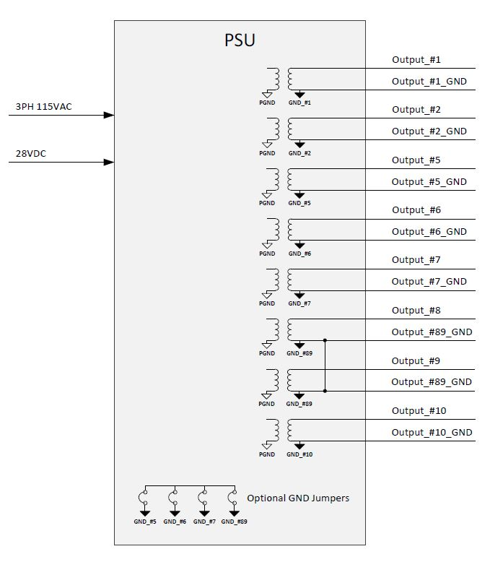
Figure ‎3-3- PSU DC Outputs

    - Settling Time
When the PSU is switched ON, or when the input voltages are reapplied from any off state, all output voltages will reach their specified values within 2.5 sec.
The PSU DC outputs ramp up time of each output shall not exceed 50ms.
The PSU DC outputs turn on shall not be affected by the following load characterization:
- The load maximum input capacitance as defined in Table ‎3-2.
- The load can turn on above 10VDC with "Start-up Current"
- "Start-up Current" of each load shall not exceed 20% of (output maximum continuous power / nominal voltage) as defined in Table ‎3-2

    - Protections
The PSU shall include the following protections:

Over-Current Protection
All regulated outputs shall be overload protected. No damage shall occur if these outputs are short-circuited. The required overcurrent protections per output are detailed in Table ‎3-2.
After the protection has been activated, the power supply will automatically try to restart outputs every 1 second if the fault has cleared.

Over-Voltage Protection

Input over voltage protection
The PSU shall protect itself, in case of input voltage surges/spikes that meet the MIL-STD-704 A & F.
Input over voltage protection shall occur if the input voltages to the power supply exceeds input OVP levels as follows:
- 28VDC transient up to 90VDC.
- 28VDC steady state up to 55±5VDC.

- 115VAC transient above 180VAC.

If the maximum voltage limit & time limit exceeding the MIL-STD A & F curves limits, the unit shall automatically shut down in order to protect itself.
In this situation, the power supply will shut down all outputs and digital communication lines and monitor the input voltages. When the input voltages are within the nominal operating range for at least 1 second, the PSU shall start a power-up sequence (check every 1 second).

Output over voltage protection
All main outputs shall be over-voltage protected. If any output voltage exceeds the corresponding over-voltage trip point threshold for more than the rated duration, the PSU shall immediately disable the faulty output and send an emergency shutdown discrete to the MIU, and then turn off all remaining outputs after corresponding hold-up time.
After the over-voltage protection has been activated, the PSU shall turn-on again only after the ON/OFF switch is driven low and then asserted high again after a minimum period of 1 second (i.e. no automatic recovery after an output over-voltage fault event).

All outputs shall be over-voltage protected according to the following table:
Table ‎3-3- Output Over-Voltage Protection Parameters
Voltage | O.V. Trip Point | Detection Response Time
115VAC | 125VAC (TBC) | 100msec (TBC)
28VDC | 35 ±1VDC | 2ms ± 0.4ms  TBR
30.5VDC | 31.5 ±1% | 2ms ± 0.4ms  TBR
36VDC | 45 ±1VDC | 2ms ± 0.4ms  TBR

Under-Voltage Protection
All main inputs shall be under-voltage protected. If any input voltage is in an under-voltage state, for more than the rated duration, the PSU shall issue to the MIU an emergency shutdown discrete and then disable all outputs after corresponding hold-up time.
After the voltage returns to the nominal value for at least 1 second, the PSU shall automatically return to normal operation, and re-enable the outputs.
Table ‎3-4- Input Under-Voltage Protection Parameters
Input Voltage | U.V. Trip Point | Response  Time
115VAC | Trip point is 95±1V, and below 90±1V immediately shut-down sequence. | 500 msec
28VDC | Turn-on threshold shall be 20±1V, and turn-off threshold shall be 17±1V. Below the turn-off threshold, the PSU shall immediately initiate a shut-down sequence. | 500 msec

Input Fuses / Circuit Breakers
The 28VDC input line shall have a 30A fuse.
There shall be 4 fuses on the 3–phase 115VAC inputs: one fuse for each of the phases plus one for the neutral line.
The 3–phase fuses shall be 15A- [TBR]. (Slow blow).
As a design goal the fuses shall be implemented with circuit breakers accessible from the PSU outside panel (provided volume limitations can be maintained).
If implemented as fuses – then the fuse housings shall be accessible from the PSU outside panel without requirement of opening the PSU box.

Over-Temperature Protection
The PSU shall shut down in the event of overheating to protect itself. The PSU shall notify the MIU via communication interface and shall initiate a power shut-down sequence by indicating the shutdown discrete to the MIU and allowing 10 seconds for the MIU to shut-down the system in an orderly fashion. After the temperature drops back below a safe level (TBD( by Manufacturer) - hysteresis, the outputs shall return to their normal operation.

Reverse-Voltage Protection
Reverse-voltage protection shall be implemented, so that 28VDC input voltage reversal will not damage the PSU. After the polarity changes back to normal, the PSU shall work normally.
In the event of reverse voltage, all outputs shall be powered off.

Missing-Phase Protection
Missing-phase indication and protection shall be implemented in the PSU, so that 115VAC missing-phase will not damage the PSU. After the missing-phase comes-up to normal, the PSU shall work normally.
In the event of a missing phase, the PSU shall issue to the MIU an emergency shutdown discrete and then all outputs shall be set to off after corresponding hold-up time.

Physical Characteristics
    - Weight
The PSU weight shall not exceed 12Kg (TBR).
    - Dimensions
The mechanical dimensions and interfaces are shown in drawings:
The dimensions of the box are 310x230x209.5 (mm).

    - Color
The PSU color shall be as follows:
- Primer: per MIL-DTL-53022 TY 2 (ELOP P/N 1179-0072-00).
- Top coat: per MIL-PRF-85285 TY I , COLOR 26250 (Gray) per FED-STD-595 (ELOP P/N 1179-0086-00).

External Interface
The diagram below provides an overall view of the PSU external interfaces. The detailed specification of each interface signal shall be provided in a separate Electrical ICD (EI) document.
Legend
Communication
Discrete Signals
Power

Figure ‎3-4- PSU External Interfaces
All the logical interfaces to the pod internal units (discrete signals & communication) shall be floating / isolated from chassis and system ground – see Section 3.2.8 - paragraph (i).

AIRCRAFT - PSU Interface
- 115VAC 3Ø + N, 400Hz
- 28VDC
- ON/OFF Discrete (dry contact: Open = PSU OFF, Close = PSU ON).
- Pod Status Discrete (High Z = Lamp OFF ; 28VDC from A/C = Lamp ON).
Note:
The 28VDC positive side which is provided by the aircraft is looped back to the lamp. The return line is in the aircraft itself.

PSU-MIU Interface
- 28VDC for MIU power
- 28VDC for FMC/MOTOR power via MIU
- Output Discretes (x4):
  - Reset signal
  - Shutdown signal
  - Emergency shutdown
  - Spare x1
All discrete output signals will be implemented by open-drain opto-coupler isolated output. All isolated outputs will be referenced to a common isolated return signal.
Outputs shall be able to operate with pull-up voltage range of 3.3V to12V.
Outputs shall be able to sink a maximum current of 5mA with Vout max <0.3V.
Output polarity shall be defined for each Discrete signal.
All isolated outputs will be protected from over voltage and reverse voltage by low leakage TVS.
- The communication interface shall be 100MbEth

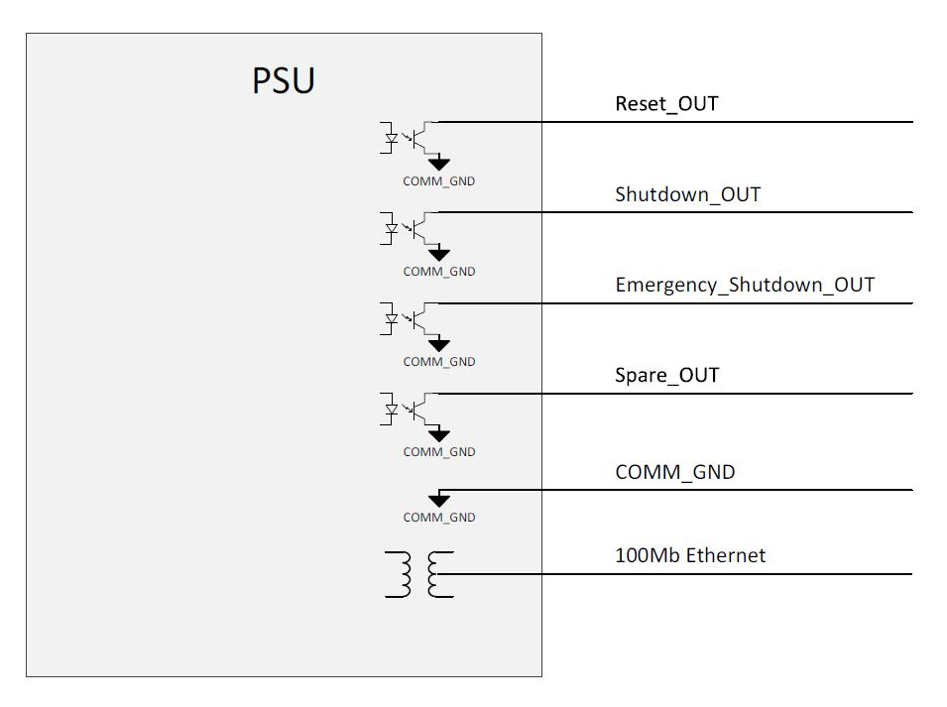
Figure ‎3-5- PSU Interfaces to MIU

PSU-Test Panel Interface
- Sampled Input 28VDC
- Sampled Input 115VAC (each phase)
- Input power status to LED on test panel (V_{LED}=5V +/- 5%, I_{LED} - up to 25mA (Typical 17mA)).
- Output power status to LED on test panel (V_{LED}=5V+/- 5%, I_{LED} - up to 25mA (Typical 17mA)).

PSU-INS Interface
- 28VDC

PSU-Camera Interface
- 28VDC for VNIR channel
- 28VDC for S&M channel
- 28VDC for MCC and motors (BS, focusx3, filter)
- 30.5VDC for MWIR Cooler
- 36VDC for FANs CCA

PSU-ADLS Interface
- 115VAC 3Ø + N, 400Hz

PSU-EDU Interface
- 115VAC 1Ø + N, 400Hz
- 28VDC

PSU-SPARE Interface (FFI)
- 28VDC

PSU-TCU Interface
- Inhibit discrete x2 (one for EC-TCU and one for CC-TCU)
Opto-coupler shall support up to 100mA load and protected from voltage spikes.
Figure ‎3-6- TCU Inhibit Interface

Plug & Play interface for a Testing Equipment
This paragraph has been tailored out.

Mechanical/Thermal Interface

Thermal Interface
In case required, the PSU may consist of provision for self-ventilation (forced air convection) by using fan(s).

Mechanical Interface
The PSU mechanical interface shall be based on a box chassis. The box shall be mounted on a tray with standard hooks and pins for quick disassembly. The unit shall include lifting handles.
The tray interface shall be designed to fit the pod structure.
If required, in order to withstand shock & vibration, the tray may include vibration mounts in order to damp the shock and vibration induced to the box.

Internal Interface
This paragraph has been tailored out.

Safety
The PSU shall be designed, fabricated and integrated to prevent injury to the operators and maintenance personnel. Safety features shall be incorporated so that any component failure will not result in conditions hazardous to the aircraft or personnel, in accordance with MIL-HDBK-454B, Requirement 1.
Safety requirements shall be guided by MIL-STD-882E Standard Practice for System Safety & MIL-STD-1472G.

Capacitor Discharge
When the PSU is turned off, the external accessible interfaces capacitors shall discharge to a voltage below 30V within 2 seconds.

Reliability
The following paragraphs describe quantitative reliability requirements for the PSU. Reliability calculations shall be performed according to MIL- HDBK-217F Notice 2.

Reliability Prediction
The reliability prediction shall be performed using the data of the stress analysis method – thermal data and (e.g.: the MIL-HDBK-217 data base - the “Part Stress Analysis") per the environmental conditions specified in this specification.
Environment: AUF (Airborne Uninhibited Fighter).
The temperature per operating scenario shall be segmented as follows:
Table ‎3-5- Altitude-Temperature Table for Reliability Prediction
ALTITUDE | MAX BOX AMBIENT °C | TYPICAL BOX AMBIENT °C | % OF TIME
Sea Level | 55 | 45 | 15
20 kft | 45 | 35 | 20
30 kft | 35 | 25 | 50
50 kft | 20 | 15 | 15

Specified MTBF
The MTBF of the PSU shall be at least 10,000 (TBR) hours according to paragraph 3.7.1, excluding the removable flash memory unit.

Service Life
Wear out is defined as the start where the cost of overhaul or repair exceeds half the cost of replacement of the Item.
The total Service Life is defined as the time interval from the beginning the Item is declared operational until wear out. This includes: Operational service life (e.g.: in-flight, on-ground operating,), on-ground non-operating, and storage.

The PSU shall have a total service life of no less than 25 years.

Operational Reliability

The minimum Mean-Time-Between-Maintenance-Action (MTBMA) hours throughout the operating service life of the equipment.
The MTBMA is measured when operated in any mode or combination of modes and under average environmental conditions. Maintenance Actions include responses to verified failure of the equipment, failure indications that result in a Can Not Duplicate (CND) or Bench Test OK (BTOK) disposition, and physical deterioration/degradation of the equipment.
The required MTBMA shall be no less than the required MTBF.

Maintainability
The following paragraphs describe the maintenance requirements of the PSU.

Maintenance Design Guide Lines
The maintenance design of the PSU shall be guided by the following principles:
- Ground support personnel shall be kept to the minimum possible.
- The design will allow rapid malfunction detection/diagnosis, fault isolation and corrective maintenance.
- PSU design shall be interlaced with the testing LRP design (BIT and ground test equipment) in order to allow failure detection when the LRP shall be still on the ground.
- Electronics units packaging shall allow rapid repair capability. The electronic units shall be packaged as plug-in printed circuit modules or assemblies. This packaging concept, coupled with the defined spares.
- LRP testing and technical manual shall result in a short repair time at ‘I’ level of maintenance.
- Panel connectors shall contain spare pins in accordance with MIL-HDBK-454, guideline 10 as feasible.
- Modules and PCB assemblies shall include the necessary mechanical interlocks, orientation and removal aids, visual aids (arrows, reference designations, etc.), and key connector necessary to prevent installation errors.
- SRUs shall enable alignment and calibration without using extended cards.
- Packaging shall be designed, as possible, to allow accessibility to replaceable items, to adjustment points, test points and test connections with no need for subassembly unit removal.

Test Points and Test Connectors
Test points in the PSU shall permit fault isolation to SRU level. PSU test connectors shall be provided to allow fault isolation to the module/PCB level upon LRU testing.
Table ‎3-6- Corrective Maintenance Required Times
Maintenance Task | MTTR (hour/s) | MaxCT (90%) (hour/s)
‘O’ Level Maintenance Activities on the aircraft, including: Isolation of failure to LRU level, removal of malfunctioning LRU, installing new LRU and verifying serviceability by OLTE. | 2 | 4
‘I’-Level Maintenance Activities, including:  Isolation of failure to SRU level, removal of malfunctioning SRU, installing new SRU and verifying serviceability by ILCTE. | 2 | 4

Serial Number Indication
The PSU shall provide an indication of its serial number & part number. The indication shall be accessible by MIU via communication and recorded in the PSU internal log file.
The serial number & part number can be updated via dedicated pins on PSU connector.

Elapsed Time Indication (ETI)
Each of the PSU shall provide a digital Elapsed Time Indication with resolution of hours. This information shall be provided along with the serial number indication. The indication shall be accessible by MIU via communication and recorded in the PSU internal log file.
The elapsed Time indication (ETI) will be saved in dedicated memory and it will be written to the Flash Memory in parallel.
The elapsed Time indication (ETI) can be updated / restored via dedicated pins on PSU connector.

The ETI shall be accessible / data shall be restored in case of most types of PSU malfunctions.

Elapsed Time Meter (ETM)
This requirement has been removed.

Software/firmware upload
In case of the operational software/firmware is damaged (i.e. – due to unplanned shutdown. power loss, etc…) and the PSU can’t power up, the PSU shall have a basic backup software/firmware which shall allow minimal communication in order to re-upload the updated software/firmware versions.
Uploading updated software/firmware to the PSU shall be possible via PSU connector without the need of removal of the PSU cover. This can be performed via dedicated pins on PSU connector.

Testability

Built In Test
The item shall have a BIT capability as follows:

Power Up BIT – performed upon startup
During the power-up sequence, the PSU shall perform a Power-Up BIT, which shall include PSU initialization and self-testing procedures necessary to reach and verify the operational functionality of the PSU. This shall include tests of the internal CPU and memory.
Power up time, including initial initializations and PUBIT duration, shall not exceed (TBD) seconds.
PUBIT shall detect at least 95% of PSU failures.

Periodic BIT – performed periodic
This category of BIT shall be performed periodically, while not interfering with normal PSU operation (unlike Power-Up BIT). This BIT shall monitor all output voltage statuses, fan speed & temperature. Periodic BIT cycle time is part of the PSU-MIU communication and shall be described in the PSU-MIU ICD document.
PBIT shall detect at least 80% of PSU failures.

Interface to a Testing Equipment
The ‘I’-Level test equipment shall interface fully to all the PSU connectors allowing it to simulate external signals and read the PSU output signals, including full communication providing control and statuses.

Version Control of Programmable Components
- Programmable components (Not including DC to DC controllers) in the SRUs (including memories hosting firmware and CPLD/FPGA components) shall be programmed in system, without the need to remove the PSU cover, through external connection.
- Exception: SRU serial number and elapsed time indicator reset shall not be able to be programed via the external connector.
- The PSU shall allow identification of each programmable component version by external means/mechanism without the need to remove the PSU cover.

Environmental Requirements
The PSU will withstand and operate with no degradation in performance when or after being subjected to the following conditions.

Temperature Altitude
The PSU shall comply with the temperature vs. altitude requirements per MIL HDBK 5400 Class II equipment. The low temperature is modified to be –40°C (including cold start). The high temperature operation shall be limited to ambient temperature of +60°C. The illustration of this requirement is given in the figure below.

Normal continuous operation
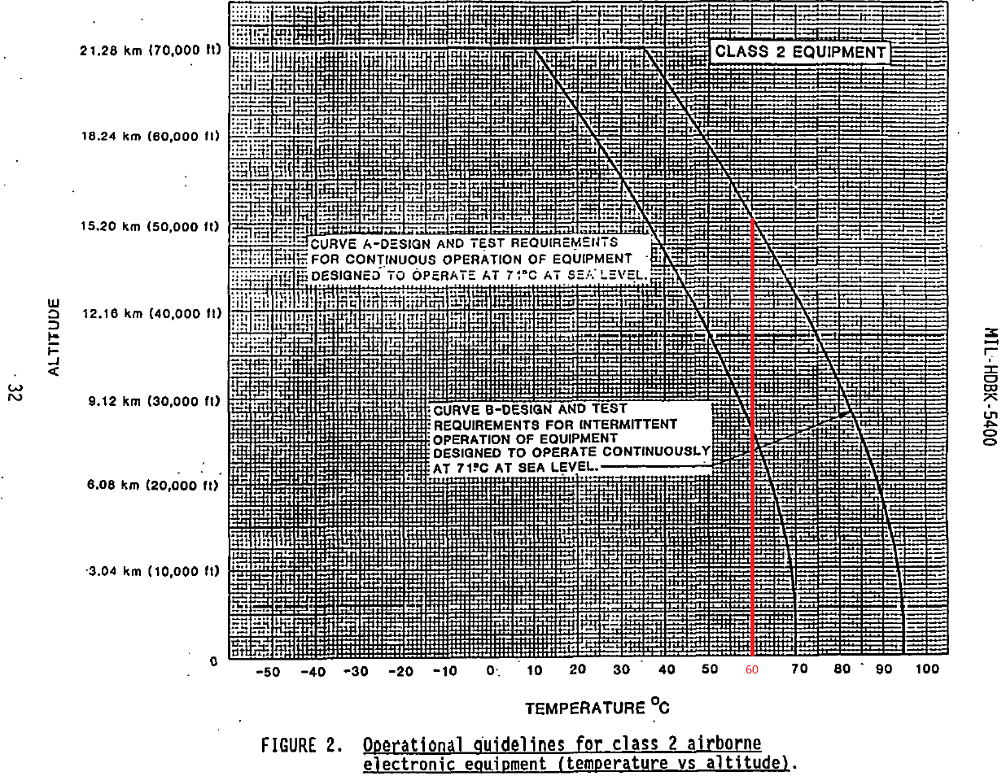
Based on MIL HDBK 5400 Class II equipment, the PSU shall operate continuously, while meeting all specified performance requirements, at any combination of high temperature and altitude as depicted in the graph below, curve A.

Figure ‎3-7- Temperature-Altitude requirement diagram

Intermittent operation
Based on MIL HDBK 5400 Class II equipment, the PSU shall be capable for an intermittent time limited (1/2 hour) operation at any combination of high temperature vs. altitude as depicted in the graph above, curve B.

Non operating
The PSU shall be able to withstand without damage, and operate according to the requirements after, exposure to the temperature-altitude combination of: -54° ÷ + 95°C from sea level to 65,000 ft.

Humidity
The PSU shall withstand exposure to external ambient humidity according to MIL-STD-810G, method 507.5, procedure II, aggravated.

Explosive atmosphere
The PSU shall not cause ignition of an explosive ambient of gaseous mixture in open air when operating in such atmosphere, as defined in MIL-STD-810G, Method 511.5, Procedure I, Explosive Atmosphere.

Acoustic Noise
The PSU shall operate within full performance when subjected to an overall sound pressure level of 140 dB. Noise frequency spectrum will be in accordance to MIL-STD-810G method 515.6 for instrumented pod store type.
Procedure I – Diffuse Field Acoustic Noise
Procedure II – Grazing Incidence Acoustic Noise

Shock
The PSU, when mounted on shock mounts, in non-operational or standby mode, shall withstand exposure to 3 shock pulses in each of the six principal directions in accordance with MIL-STD-810G Method 516.6:
- Procedure I – functional shock, FIGURE 516.6-10. (20g x 11 msec, saw tooth).
0.05P
0.07D
D
0.3P
0.07D
0.2P
P
0.05P
0.15P
0.3D
Ideal sawtooth pulse
0.15P
Tolerance limits
Ref line zero
Where: D=11 msec, P=20g
Figure ‎3-8: Shock pulse diagram
- Procedure IV – Transit Drop inside package.
- Procedure VI – Bench Handling

Sand and dust
The PSU shall withstand exposure to dust while non-operating. The PSU shall be operational within its required performance immediately after removal of sand and dust environment in accordance with MIL-STD-810G Method 510.5, procedure I (blowing dust).

Fungus
The PSU materials selected shall not serve as nutrients for fungus growth. Determination of fungi and moisture resistance shall be as specified in MIL-HDBK-454, guideline 4 and MIL-STD-810G method 508.6.

Salt atmosphere
The PSU shall withstand exposure to salt atmosphere in accordance with MIL-STD-810G method 509.5.

Acceleration
The PSU, in operating mode and in non-operating mode, shall withstand constant acceleration of 7g in every direction in accordance with MIL-STD-810G method 513.6, procedure I (structural test) and procedure II (operational test).

Vibration
The PSU shall be able to withstand without any damage, and operate according to the requirements during and after exposure to random vibration levels in each of the 3 axis in accordance with MIL-STD-810G Method 514.6, procedure I (general vibration).
The axis are with relation to the pod flight direction whereas:
- X-Axis: Forward-backward (from pod nose)
- Y-Axis: Right-Left
- Z-Axis: Up-down

Normal continuous operation
The PSU shall operate without degradation in performance under vibrations with the following PSD:
X Axis
Freq. | PSD
5.0 | 1.51E-06
6.0 | 1.03E-06
7.0 | 2.39E-06
8.0 | 2.93E-06
9.0 | 1.80E-06
10.0 | 5.01E-06
11.0 | 3.98E-06
11.8 | 1.39E-06
12.9 | 1.05E-06
16.7 | 2.71E-06
18.8 | 1.47E-06
22.5 | 1.80E-05
23.9 | 1.67E-05
26.3 | 5.01E-06
27.7 | 8.15E-06
29.8 | 5.99E-06
31.1 | 6.31E-06
33.1 | 1.36E-05
34.2 | 6.81E-06
39.6 | 5.55E-06
41.3 | 1.17E-05
45.4 | 1.36E-05
49.3 | 5.14E-06
53.1 | 1.00E-05
54.8 | 7.94E-06
71.4 | 1.14E-04
82.7 | 6.47E-05
86.4 | 4.30E-04
93.0 | 5.70E-04
103.1 | 6.64E-05
118.1 | 3.16E-05
134.0 | 9.75E-05
144.3 | 9.26E-05
153.5 | 3.41E-05
168.8 | 9.50E-05
183.7 | 1.14E-04
210.9 | 1.05E-03
241.8 | 1.36E-03
292.1 | 1.43E-03
310.9 | 7.74E-04
345.5 | 1.36E-03
375.7 | 1.47E-03
391.6 | 6.64E-04
435.9 | 8.80E-03
478.4 | 1.85E-03
515.2 | 3.69E-03
536.8 | 1.54E-03
602.5 | 1.76E-03
676.0 | 1.11E-03
759.8 | 5.99E-03
917.0 | 2.39E-03
956.7 | 3.88E-03
976.4 | 2.00E-03
1216.8 | 1.54E-03
1270.2 | 4.52E-03
1394.9 | 1.90E-03
1703.2 | 2.78E-03
1796.1 | 5.70E-03
2000.0 | 3.08E-03
Grms | 2.2

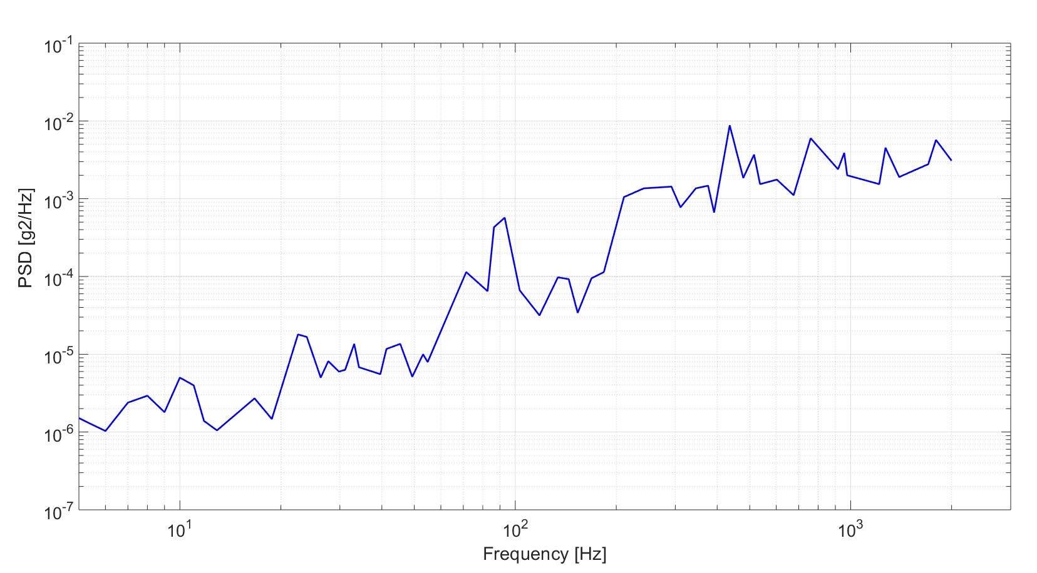

Y Axis
Freq. | PSD
5.0 | 1.36E-05
6.0 | 1.03E-05
7.0 | 6.47E-05
8.0 | 9.03E-05
9.0 | 6.99E-05
10.0 | 1.51E-04
11.0 | 2.05E-04
13.1 | 3.41E-06
15.2 | 4.30E-06
15.9 | 3.41E-06
16.9 | 7.74E-06
20.4 | 4.08E-06
25.1 | 1.63E-05
26.2 | 1.20E-05
28.2 | 1.54E-05
34.8 | 1.67E-04
37.0 | 1.20E-04
40.7 | 6.15E-04
42.9 | 6.99E-04
45.6 | 5.55E-04
48.1 | 1.80E-04
53.4 | 1.85E-04
65.8 | 4.89E-05
73.1 | 6.99E-05
77.9 | 5.70E-05
83.8 | 1.63E-04
88.3 | 7.74E-05
100.1 | 1.47E-03
108.8 | 1.76E-03
128.7 | 2.39E-04
137.0 | 2.27E-04
139.9 | 3.33E-04
152.2 | 1.85E-04
163.7 | 3.00E-04
174.4 | 2.51E-04
210.5 | 5.01E-03
219.5 | 1.23E-03
236.2 | 1.43E-03
254.2 | 3.41E-03
265.1 | 1.85E-03
282.3 | 2.58E-03
300.6 | 1.08E-03
323.4 | 1.26E-03
359.1 | 5.01E-03
390.5 | 2.85E-03
420.2 | 9.03E-03
447.4 | 1.17E-02
507.4 | 1.29E-02
575.3 | 4.30E-03
666.1 | 2.85E-02
795.9 | 1.54E-02
847.5 | 1.20E-02
893.0 | 5.84E-03
941.0 | 2.10E-02
1089.6 | 2.15E-02
1197.3 | 7.74E-03
1248.5 | 2.15E-02
1460.8 | 1.29E-03
1673.9 | 1.20E-03
1898.0 | 2.64E-04
2000 | 0.0005995
Grms | 3.9
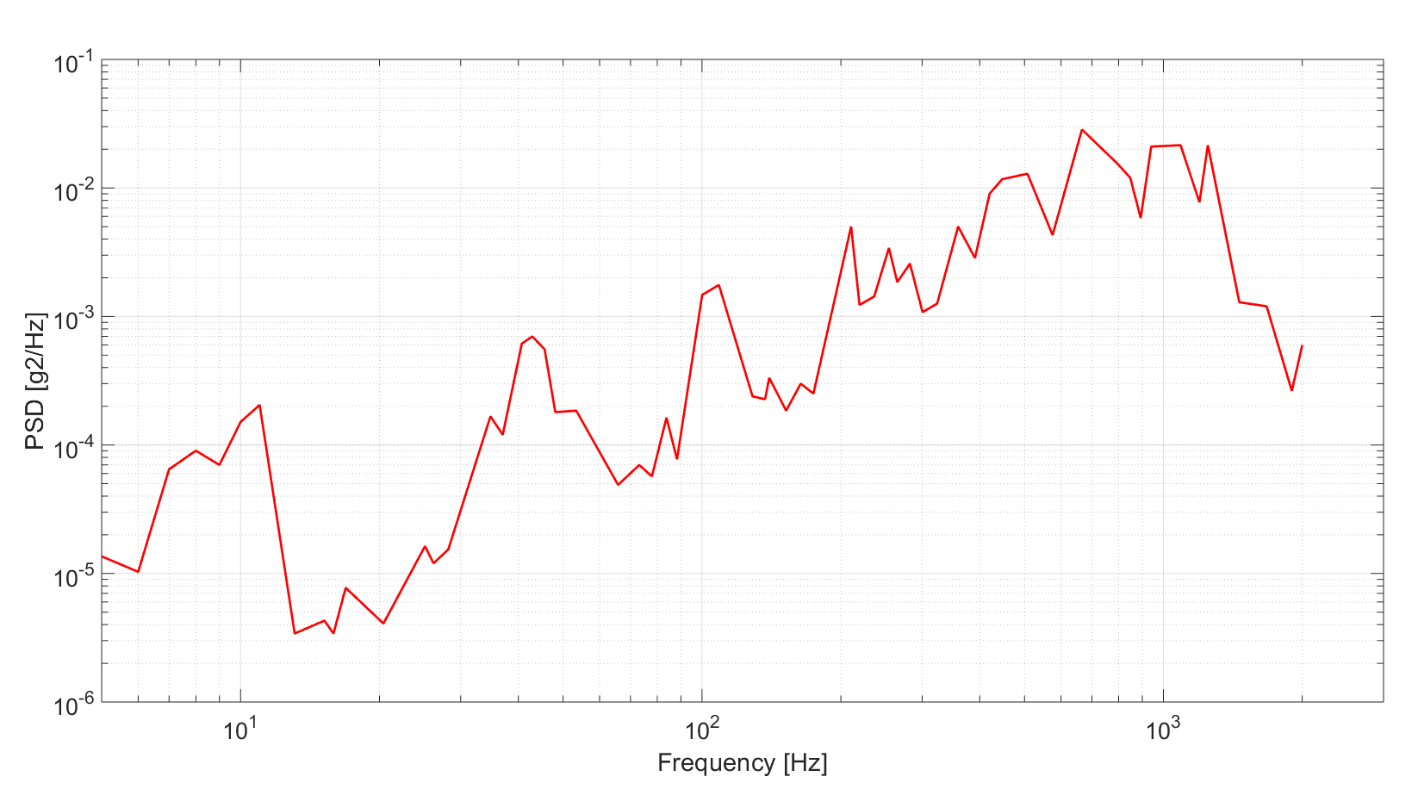

Z Axis
Freq. | PSD
5.0 | 1.36E-05
6.0 | 1.51E-05
7.0 | 1.08E-04
8.0 | 9.75E-05
8.9 | 6.31E-05
10.1 | 2.39E-04
11.0 | 2.33E-04
13.0 | 3.24E-06
14.0 | 2.71E-06
16.5 | 1.85E-05
18.0 | 1.80E-05
19.1 | 1.23E-05
21.9 | 6.15E-05
23.8 | 4.19E-05
25.9 | 4.89E-05
27.6 | 1.29E-04
32.6 | 1.63E-04
34.8 | 3.98E-05
38.2 | 4.64E-05
39.8 | 3.59E-05
42.0 | 1.63E-04
44.2 | 2.00E-05
49.1 | 9.75E-06
52.3 | 4.08E-05
54.5 | 3.00E-05
59.9 | 7.74E-05
69.4 | 1.03E-04
71.6 | 1.85E-04
80.3 | 1.43E-04
86.5 | 3.00E-03
93.0 | 5.01E-03
101.2 | 1.85E-03
111.2 | 1.33E-04
131.4 | 3.78E-04
150.6 | 1.00E-04
191.6 | 2.39E-04
212.7 | 1.33E-03
226.5 | 7.36E-04
254.2 | 5.41E-03
270.7 | 8.15E-04
359.1 | 7.55E-04
394.6 | 3.16E-03
452.2 | 2.15E-03
476.5 | 1.63E-03
666.1 | 1.71E-02
812.7 | 2.00E-02
931.2 | 2.45E-03
991.6 | 1.08E-02
1023.3 | 3.00E-03
1184.8 | 6.31E-03
1315.6 | 3.00E-03
1430.6 | 6.47E-03
2000.0 | 1.36E-02
Grms | 3.7
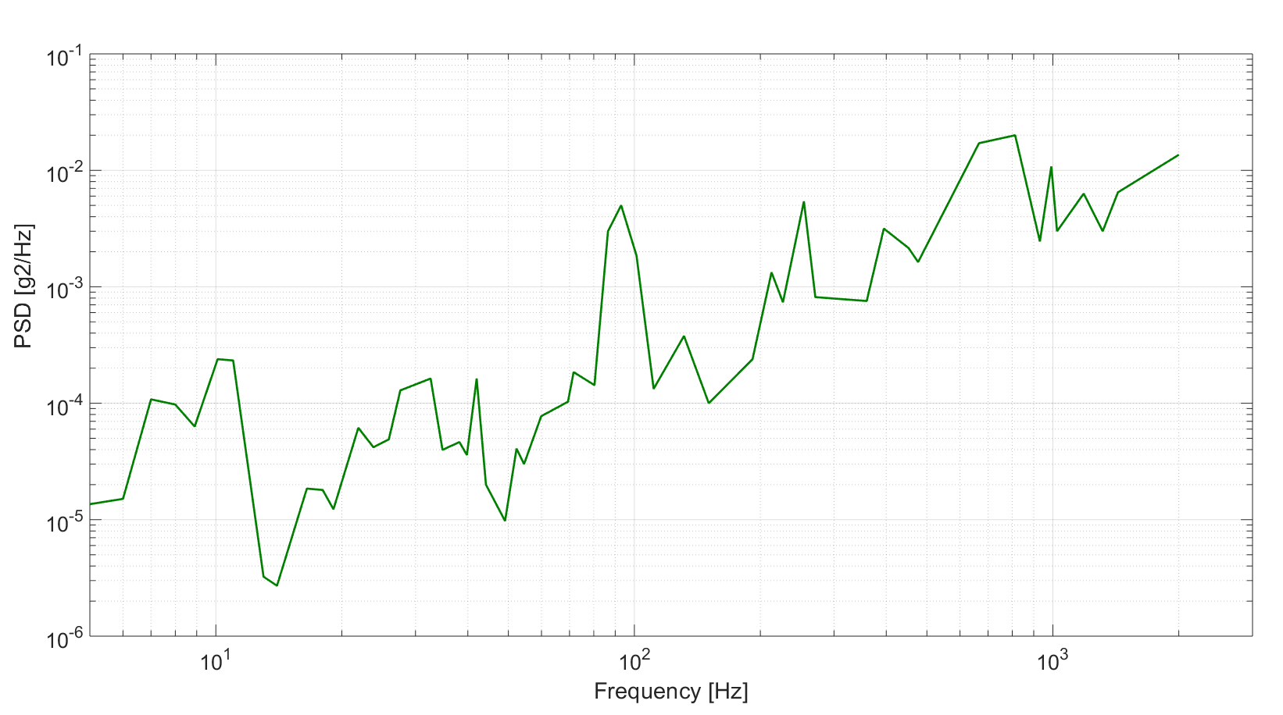

Endurance
The PSU shall be able to withstand without any damage, and operate according to the requirements, after exposure to vibration levels with the following PSD for 1 hour in each axis.

Freq. | PSD
5.0 | 3.25E-06
6.0 | 2.22E-06
7.0 | 5.16E-06
8.0 | 6.33E-06
9.0 | 3.89E-06
10.0 | 1.08E-05
11.0 | 8.60E-06
11.8 | 3.01E-06
12.9 | 2.27E-06
16.7 | 5.86E-06
18.8 | 3.17E-06
22.5 | 3.89E-05
23.9 | 3.60E-05
26.3 | 1.08E-05
27.7 | 1.76E-05
29.8 | 1.30E-05
31.1 | 1.36E-05
33.1 | 2.94E-05
34.2 | 1.47E-05
39.6 | 1.20E-05
41.3 | 2.52E-05
45.4 | 2.94E-05
49.3 | 1.11E-05
53.1 | 2.16E-05
54.8 | 1.72E-05
71.4 | 2.46E-04
82.7 | 1.40E-04
86.4 | 9.29E-04
93.0 | 1.23E-03
103.1 | 1.44E-04
118.1 | 6.83E-05
134.0 | 2.11E-04
144.3 | 2.00E-04
153.5 | 7.38E-05
168.8 | 2.05E-04
183.7 | 2.46E-04
210.9 | 2.27E-03
241.8 | 2.94E-03
292.1 | 3.09E-03
310.9 | 1.67E-03
345.5 | 2.94E-03
375.7 | 3.17E-03
391.6 | 1.44E-03
435.9 | 1.90E-02
478.4 | 3.99E-03
515.2 | 7.97E-03
536.8 | 3.34E-03
602.5 | 3.79E-03
676.0 | 2.39E-03
759.8 | 1.30E-02
917.0 | 5.16E-03
956.7 | 8.39E-03
976.4 | 4.31E-03
1216.8 | 3.34E-03
1270.2 | 9.78E-03
1394.9 | 4.10E-03
1703.2 | 6.01E-03
1796.1 | 1.23E-02
2000.0 | 6.66E-03
Grms | 3.2
X Axis

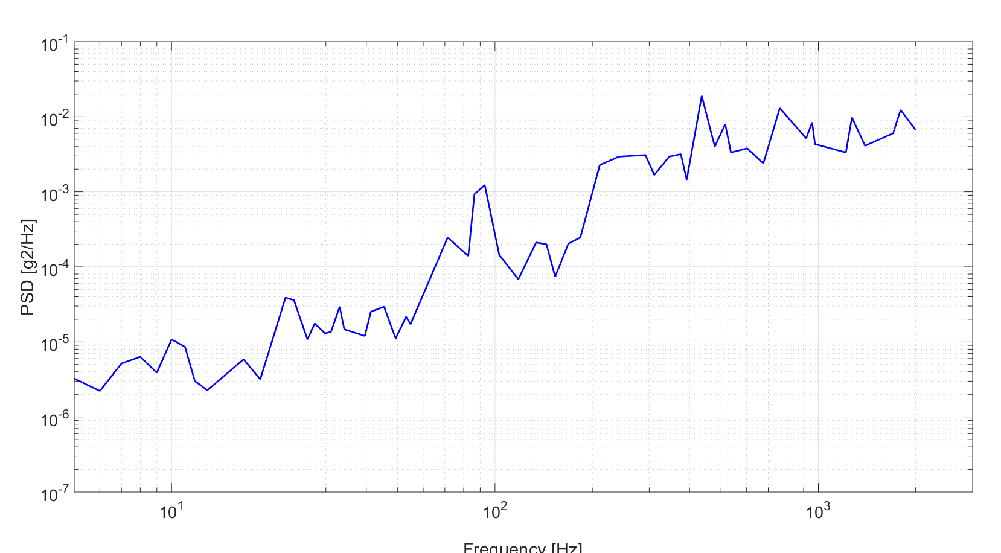

Y Axis
Freq. | PSD
5.0 | 2.94E-05
6.0 | 2.22E-05
7.0 | 1.40E-04
8.0 | 1.95E-04
9.0 | 1.51E-04
10.0 | 3.25E-04
11.0 | 4.42E-04
13.1 | 7.38E-06
15.2 | 9.29E-06
15.9 | 7.38E-06
16.9 | 1.67E-05
20.4 | 8.83E-06
25.1 | 3.51E-05
26.2 | 2.58E-05
28.2 | 3.34E-05
34.8 | 3.60E-04
37.0 | 2.58E-04
40.7 | 1.33E-03
42.9 | 1.51E-03
45.6 | 1.20E-03
48.1 | 3.89E-04
53.4 | 3.99E-04
65.8 | 1.06E-04
73.1 | 1.51E-04
77.9 | 1.23E-04
83.8 | 3.51E-04
88.3 | 1.67E-04
100.1 | 3.17E-03
108.8 | 3.79E-03
128.7 | 5.16E-04
137.0 | 4.90E-04
139.9 | 7.19E-04
152.2 | 3.99E-04
163.7 | 6.49E-04
174.4 | 5.43E-04
210.5 | 1.08E-02
219.5 | 2.65E-03
236.2 | 3.09E-03
254.2 | 7.38E-03
265.1 | 3.99E-03
282.3 | 5.57E-03
300.6 | 2.33E-03
323.4 | 2.72E-03
359.1 | 1.08E-02
390.5 | 6.17E-03
420.2 | 1.95E-02
447.4 | 2.52E-02
507.4 | 2.79E-02
575.3 | 9.29E-03
666.1 | 6.17E-02
795.9 | 3.34E-02
847.5 | 2.58E-02
893.0 | 1.26E-02
941.0 | 4.54E-02
1089.6 | 4.66E-02
1197.3 | 1.67E-02
1248.5 | 4.66E-02
1460.8 | 2.79E-03
1673.9 | 2.58E-03
1898.0 | 5.71E-04
2000 | 1.30E-03
Grms | 5.7
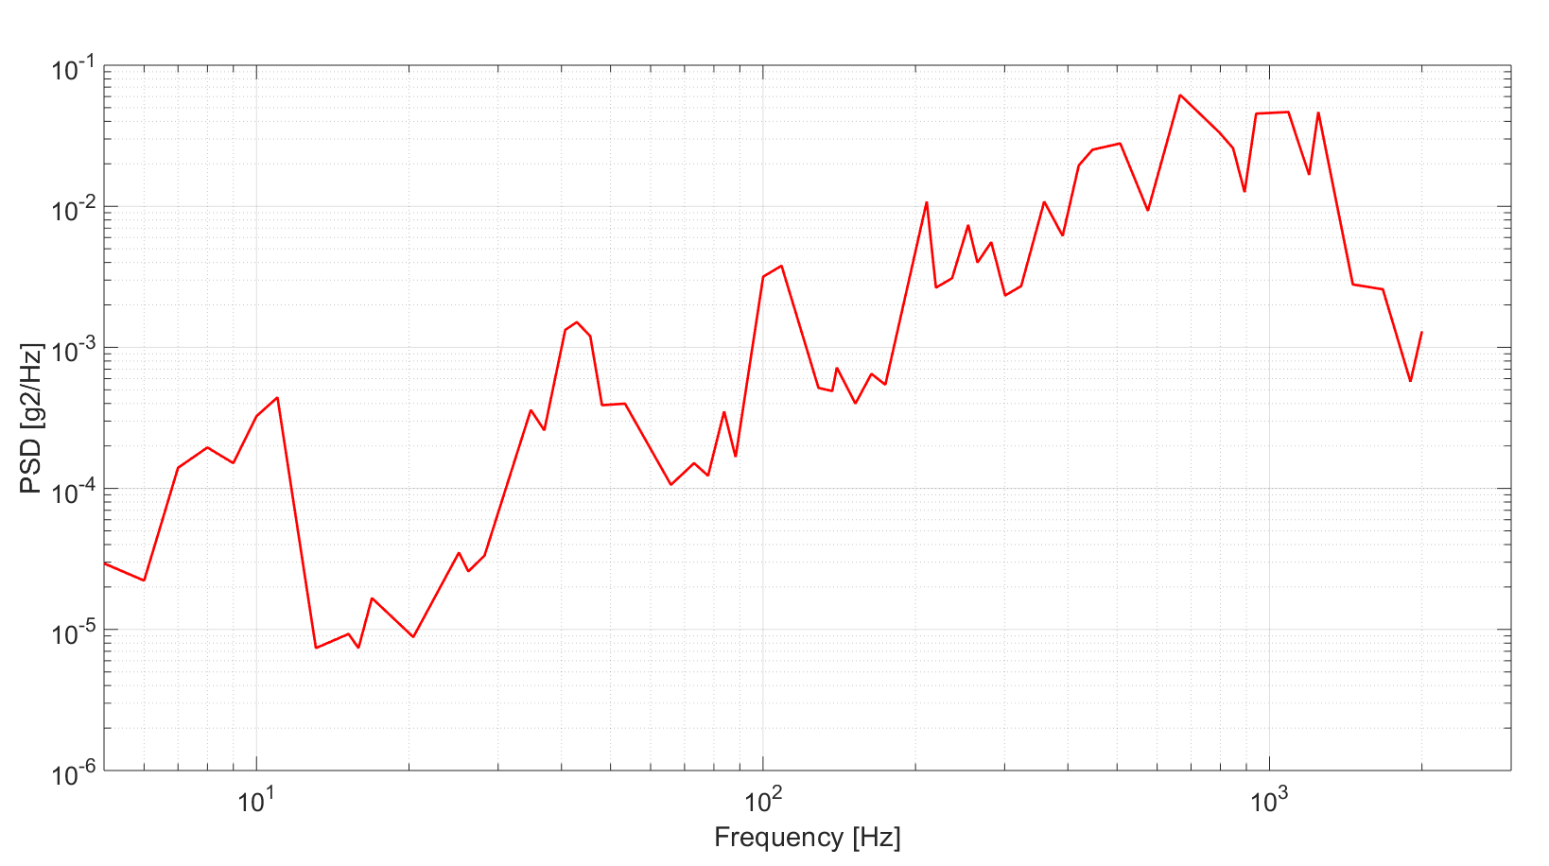

Z Axis
Freq. | PSD
5.0 | 2.94E-05
6.0 | 3.25E-05
7.0 | 2.33E-04
8.0 | 2.11E-04
8.9 | 1.36E-04
10.1 | 5.16E-04
11.0 | 5.03E-04
13.0 | 7.01E-06
14.0 | 5.86E-06
16.5 | 3.99E-05
18.0 | 3.89E-05
19.1 | 2.65E-05
21.9 | 1.33E-04
23.8 | 9.05E-05
25.9 | 1.06E-04
27.6 | 2.79E-04
32.6 | 3.51E-04
34.8 | 8.60E-05
38.2 | 1.00E-04
39.8 | 7.77E-05
42.0 | 3.51E-04
44.2 | 4.31E-05
49.1 | 2.11E-05
52.3 | 8.83E-05
54.5 | 6.49E-05
59.9 | 1.67E-04
69.4 | 2.22E-04
71.6 | 3.99E-04
80.3 | 3.09E-04
86.5 | 6.49E-03
93.0 | 1.08E-02
101.2 | 3.99E-03
111.2 | 2.86E-04
131.4 | 8.17E-04
150.6 | 2.16E-04
191.6 | 5.16E-04
212.7 | 2.86E-03
226.5 | 1.59E-03
254.2 | 1.17E-02
270.7 | 1.76E-03
359.1 | 1.63E-03
394.6 | 6.83E-03
452.2 | 4.66E-03
476.5 | 3.51E-03
666.1 | 3.70E-02
812.7 | 4.31E-02
931.2 | 5.29E-03
991.6 | 2.33E-02
1023.3 | 6.49E-03
1184.8 | 1.36E-02
1315.6 | 6.49E-03
1430.6 | 1.40E-02
2000.0 | 2.94E-02
Grms | 5.4
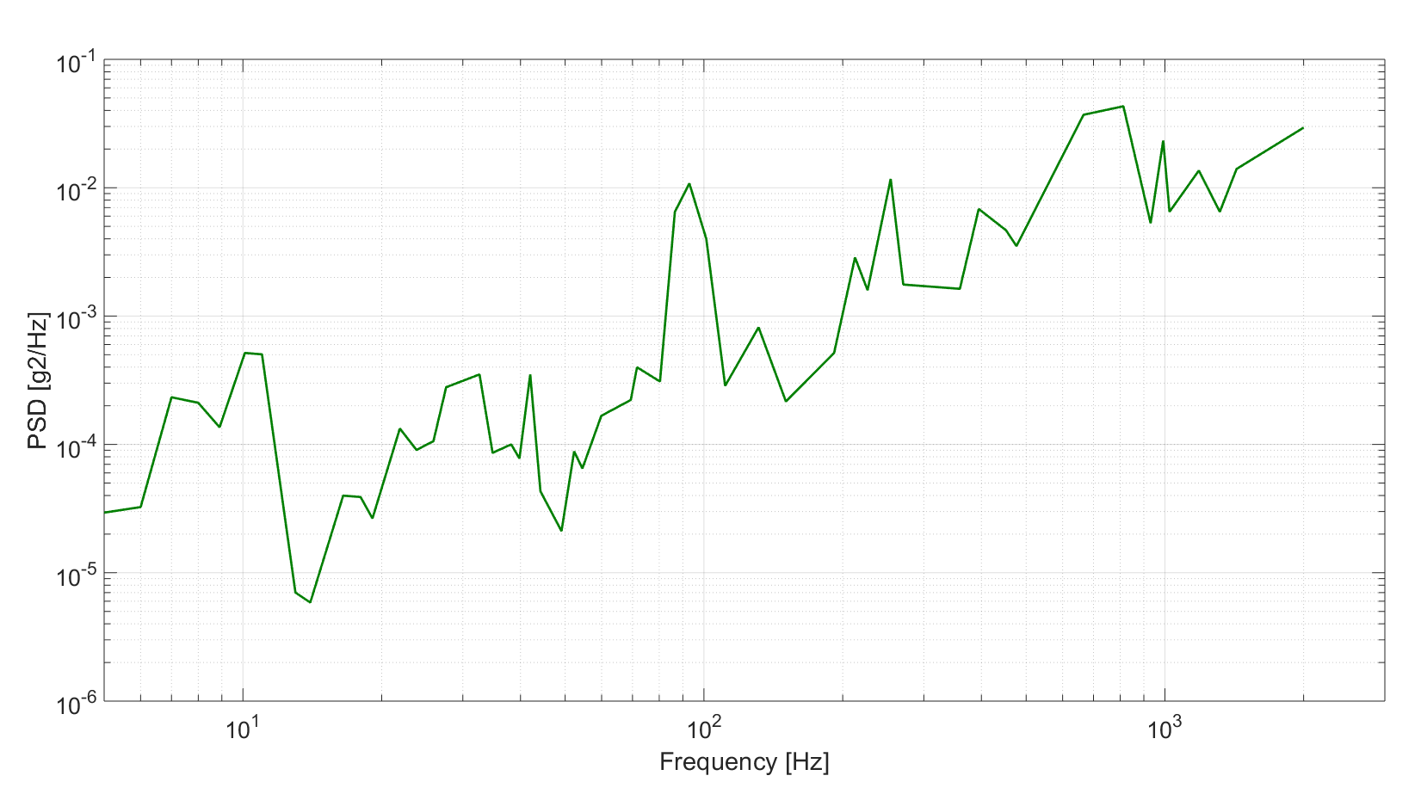

Transportability and Storage

Transportability
- Transporting the PSU overseas shall not require adjustment or calibration. The PSU shall be immediately operational upon installing it in the Condor-MS pod after being transported overseas.
- The following packaging rules shall apply for the transportation case:
- The transportation case shall be designed to have the smallest possible dimensions, and shall protect the equipment within, under transportation conditions of a vehicle on dirt roads, without structural damage.
- The case shall be sealed from penetration of moisture or rain.
- PCBs can be packed in hard cardboard packaging.
- All types of packaging shall include polyethylene foam minimum thickness of 100mm.
- The case shall have handles to enable carrying safely and comfortably.
- Marking on the case shall be environmentally durable, clearly discernable and easy to read. Warnings will be clearly visible and highlighted with illustrated signs.
- Each case shall have a label or identification plate, which will include the item name, package part number & item part number.
- On each side of the package shall be clear labels indicating “Fragile” & “This Side Up ”.

Storage
The PSU shall operate without performance degradation after withstanding the following long term storage conditions:
Temperature: 0°C to +40°C.
Humidity: 20% to 90% RH.

Design and Construction

Selection of materials, processes and parts
- Industrial “Best Practice” (BP) parts shall be used to the maximum extent possible. Military and industrial “Automotive” or “Military Temperature Only” (MTO) parts may be used if required.
- Other materials, processes and parts shall comply with the corresponding requirements in accordance with MIL-STD-883F, Method B. as long as the requirements do not contradict the specified requirements within this document.
- Use of industrial materials shall be in accordance with EP-2304, ES-1301 & GP-3200-5040-00. Military materials shall be used in accordance to the guidelines in MIL-PRF-19500M (for semi-conductors) and MIL-STD-883F class B (for micro circuits).
- Materials selection shall be based on the general requirements for non-flammability and fungus resistance in accordance with MIL-HDBK-454 guidelines 3 and 4.
- Magnesium or magnesium alloy shall not be used.
- Fans shall be selected in accordance with the following noise limit requirements:
- Exposure to steady state noise shall not exceed the limits of category D, Table 2, MIL-STD-1474D
- Exposure to impulse noise shall not exceed the limits specified for limit W, Fig. 3, MIL-STD-1474D.

Passive devices
New passive devices shall be chosen from ER (established reliability) of ES-1358, ES-1359 & ES-1324.
Termination: solder type, over Nickel beerier plating.

Sealing and insulation materials
Sealing and insulation materials will not be highly flammable. Sealing materials will not harm insulation and shall not cause damage to neighboring metal or plastic parts, either during application or as a result of aging. Printed Circuit Assemblies shall be coated in accordance with MIL-I-46058C.

Treatment and finishing
All metal surface, except for electrical contacts, shall pass anti-corrosion treatment, including treatment to prevent electrolytic reaction between two dissimilar metals.

Junction temperature
Worst case semiconductor and microcircuit junction temperatures shall not exceed manufacturer maximum junction temperature for the specific environment with 20°C safety margin.

Printed Circuit Boards (PCBs)
PCBs shall be in accordance with MIL-PRF-31032 & IPC-D275. Coating shall not be used in order to support or reinforce board components.

Electromagnetic compatibility

EMC Requirements
During any mode of operation, or while changing modes of operation, the PSU shall comply with the emission and susceptibility requirements of MIL-STD-461C & MIL-STD-461G, Air-Force category as specified herein.

Description of Requirements
Table ‎3-7- EMC MIL-STD Requirements
MIL-STD | Test  Requirement | Description | Notes
461C | CE01 | Conducted Emission, Power Leads; 30Hz-15KHz | --
461C | CE03 | Conducted Emission, Power Leads; 15KHz-50MHz | --
461C | CE07 | Conducted Emission, Power Leads | --
461C | CS01 | Conducted Susceptibility, Power Leads; 30Hz-50KHz | --
461C | CS02 | Conducted Susceptibility, Power Leads; 50KHz-400MHz | --
461C | CS06 | Conducted Susceptibility, Power Leads; Spikes | --
461C | RE02 | Radiated Emission, Electric Field; 14KHz-10GHz | --
461C | RS01 | Radiated Susceptibility Magnetic Field; 30Hz-50KHz | --
461C | RS02 | Radiated Susceptibility Magnetic & Electric Field, Spikes & Power Frequencies | --
461C | RS03 | Radiated Susceptibility, Electric Field;  14KHz-10GHz, 200V/m.  Susceptibility Signals shall be modulated as follows:  (A) Below 400MHz; 1000Hz, AM 50%  (B) Above 400MHz; Pulse Modulation 10KHz, Pulse Width 1KHz. | --
461G | CE101 | Conducted Emission; Power Leads; 800Hz -10KHz | 20dB relaxation
461G | CE102 | Conducted Emission; Power Leads; 10KHz-10MHz | --
461G | CS101 | Conducted Susceptibility; Power Leads; 30Hz-150KHz | --
461G | CS114 | Conducted Susceptibility ,Bulk Cable Injection; 10KHz-400MHz | --
461G | CS115 | Conducted Susceptibility ,Bulk Cable Injection, Impulse Excitation | --
461G | CS116 | Conducted Susceptibility , Damped Sinusoidal Transients, Power Leads; 10KHz-100MHz | --
461G | RE101 | Radiated Emission ,Magnetic Field; 30Hz-100KHz | --
461G | RE102 | Radiated Emission, Electric Field; 2MHz-18GHz | Design goal
461G | RS101 | Radiated Susceptibility, Magnetic Field; 30Hz-100KHz | --
461G | RS103 | Radiated Susceptibility, Electric Field, 200V/m; 2MHz-18GHz | Design goal
**Note:
  - CE & CS sections shall be tested at unit level and also at system (pod) level.
  - RE & RS sections shall be tested only at system (pod) level.
  - The requirements do not include a frequency of 400Hz which is the network frequency

Bonding
Electrical bonding for the LRU shall be in accordance with MIL-B-5087B.
The DC resistance between the chassis and connectors body shall be less than 2.5 mili Ω.

Grounding
All input and output voltages will be floating from the chassis.

Grounding concept
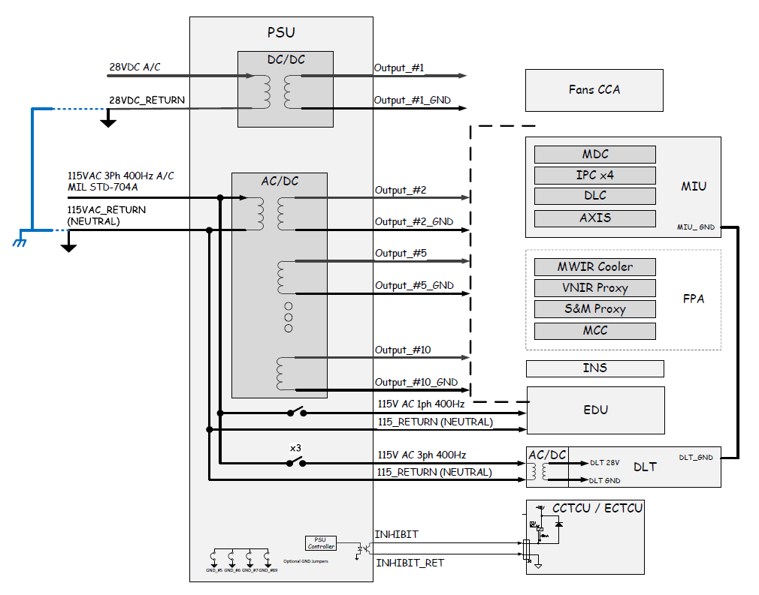

Shielding
The LRU shall be enclosed with close metallic shields.

External Cables
This requirement is not relevant for the PSU and has been removed.

Other EMC recommended instructions:
Table ‎3-8- Other EMC Instructions
Action | No.
Requirement filtering adjacent to a power supply connector. The filters should provide C.M and D.M insertion loss.
The mechanical engineer has to consider the volume of these filters (that are adjacent to a power supply connector). The default volume is 15×40×50mm.
The insertion loss of filters (Feed Thru) are:
- 20dB@200kHz D.M
- 30dB@100MHz C.M
There is an option to design these filters with discrete components.
If these filters compound from discrete components on mini card, needed to provide full ground plane. This plane shall be connected to chassis with the mechanical screws.
Locate the board adjacent to all connectors. On board compounded SMT filters. The boards must consist of a ground plane that is connected to the chassis.
All output connectors’ back-shells shall be connected electrically peripherally to the box.
The box's cover shall be connected electrically peripherally to the box. The box's structure shall be at least 5mm width with conducted chromatic coating. The cover peripheral area shall be with conducted chromatic coating.

The distance between two adjacent screws will not exceed 50mm. If the distance must be larger, there is need to use with conducted O ring or gasket.
Routing inside the box shall be adjacent to the conducting plane.
Every contact plane of box and platform shall have conducted chromatic coating
The ground screw shall be at least 8mm diameter with maximum contact resistance of 2.5 mil Ω to box's structure.
All of the connectors shall have at least one ground pin per every 4 signal pins. The ground pins shall be distributed evenly (same way as the other pins).

Nameplate and Product Marking
Nameplates and product marking shall be based on the requirements of MIL-STD-130L appropriate for the type and size of the product.
There shall be a name plate on the outside chassis (Permanent marking).
The name plate shall include the following information:
A: Serial number
B: Buyer P/N (same number as this document)
C: Revision
D: Date code (yy, mm).

Workmanship
Workmanship shall be guided by the MIL-HDBK-454 guideline 9.

Interchangeability
Interchangeability shall be guided by the MIL-HDBK-454B guideline 7.
The PSU shall be directly and completely interchangeable with respect to installation interconnection and performance without alignment.
Design tolerances should permit parts, subassemblies, and assemblies to be used in their parent assemblies without regard to the source of supply or manufacturer.

Human Performance / Human Engineering
The human engineering effort related to the unit operation shall be conducted in accordance with the guidelines of MIL-HDBK-46855A and MIL-STD-1472G guidelines. The activities for repair, assembly, installation and integration of the LRU and SRUs, shall be based on the MIL-STD-1472G for human engineering criteria.
The design will focus on aspects of human engineering, while minimizing the possibility of human error in operation and maintenance.
Removal and installation of SRUs – such as printed cards or backplane shall not require use of soldering iron or any special tools.

Precedence and Criticality of Requirements Precedence

Key Characteristics and Critical Items
This paragraph has been tailored out.

Precedence and Criticality of Requirements
This paragraph has been tailored out.

Quality Assurance Provisions

Classification of Inspections
The delivered units shall pass the following tests:

ESS – Environmental Stress Screening
All units shall pass ESS including thermal cycles and random vibrations according to ESS procedure.

Design Verification
The first unit shall pass full qualification testing including POD (Proof of Design) & EVT (Environmental Verification Test) based on the table below.

ATP – Acceptance Test
All units shall pass ATP according to ATP procedure approved by customer based on all requirements in chapter 3 of this document and indicated in the VRCM table below.

Verification Cross-Reference Matrix - VCRM
- Inspection – Visual comparison (when the prime item is not operating) against the requirements or the design (e.g.: weight, size – compared to drawings).
- Analysis – Checking the requirements withstanding by analyzing the design using mathematical models, charts, graphs, circuit diagrams, etc.
- Demonstration – Checking item functionality by operation. (This is the most common verification method).
- Test - Checking item functionality using technical means and with measurable results.

The following Verification Classes are used:
- Design Verification (Qualification) – Tests that are performed as part of hardware development tests on hardware units, including Proof Of Design (POD) and Environmental Verification Tests (EVT).
- Lab Acceptance – Formal lab tests that are performed after prime item development process completion.

KEY:
Verification Methods | Verification Classes
I = Inspection | ATP = Acceptance Test Procedure
A = Analysis | POD = Proof Of Design
S = Similarity | EVT = Environmental Verification Tests
D = Demonstration
T = Test
NA – Not Applicable (title)

The following table comprises the verification matrix.

Table ‎4-1- Requirement/Verification Cross-Reference Matrix
Paragraph No. | Requirement Description | Verification Method | Verification Class
‎3.1 | Functional and Performance | NA
‎3.1.1 | PSU Main Functionality | D | ATP
‎3.1.2 | Logic Statuses | D | ATP
‎3.1.3 | Communication Interface | D | ATP
‎‎3.1.4 | Log File Functionality | D | ATP
‎3.1.5 | ON/OFF Functionality | D | ATP
‎3.1.5.1 | System Reset (“short” reset) | D | ATP
‎3.1.5.2 | System Power Off | D | ATP
‎3.1.6 | Lamp indication | D | ATP
‎3.1.7 | Sampled voltage outputs | D | ATP
‎3.1.8 | PSU Built In Tests (BIT) | D | ATP
‎3.1.9 | Resource Utilization | T | POD
‎3.1.10 | Functionality during Input Voltage Fault Conditions | D | ATP
‎3.2 | Electrical Characteristics | NA
‎3.2.1 | Primary Input Power | T | POD
‎3.2.2 | Power Consumption (covered in para. 3.2.5)
‎3.2.3 | Inrush Current | T | ATP
‎3.2.4 | Output Power Characteristics | T | ATP
‎3.2.4.1 | Peak power consumption profile | T | ATP
‎‎3.2.5 | Efficiency | T | ATP
‎3.2.6 | Power factor correction | T | POD
‎3.2.7 | Resistance | T | ATP
‎3.2.8 | Isolation | T | ATP
‎3.2.9 | Settling Time | T | ATP
‎3.2.10 | Protections | NA
‎3.2.10.1 | Over-Current Protection | T | ATP
‎3.2.10.2 | Over-Voltage Protection | NA
‎3.2.10.2.1 | Input over voltage protection | T | ATP
‎3.2.10.2.2 | Output over voltage protection | T | ATP
‎3.2.10.3 | Under-Voltage Protection | T | ATP
‎3.2.10.4 | Input Fuses / Circuit | I (D) | ATP
‎3.2.10.5 | Over-Temperature Protection | T | POD
‎3.2.10.6 | Reverse-Voltage Protection | D | ATP
‎3.2.10.7 | Missing-Phase Protection | D | ATP
‎3.3 | Physical Characteristics | NA
‎3.3.1 | Weight | I | ATP
‎3.3.2 | Dimensions | I | ATP
‎3.3.3 | Color | I | ATP
‎3.4 | External Interface | D | ATP
‎3.4.1 | AIRCRAFT - PSU Interface | D | ATP
‎3.4.2 | PSU-MIU Interface | D | ATP
‎3.4.3 | PSU-Test Panel Interface | D | ATP
‎3.4.4 | PSU-INS Interface
‎3.4.5 | PSU-Camera Interface | D | ATP
‎3.4.6 | PSU-ADLS Interface | D | ATP
‎3.4.7 | PSU-EDU Interface | D | ATP
‎3.4.8 | PSU-SPARE Interface (FFI) | D | ATP
‎3.4.9 | PSU-TCU Interface | D | ATP
‎3.4.11 | Mechanical/Thermal Interface | NA
‎3.4.11.1 | Thermal Interface | I | POD
‎3.4.11.2 | Mechanical Interface | I | POD
‎3.5 | Internal Interface | NA
‎3.6 | Safety | A | POD
‎3.7 | Reliability | NA
‎3.7.1 | Reliability Prediction | A | POD
‎3.7.2 | Specified MTBF | A | POD
‎3.7.3 | Service Life | A | POD
‎3.7.4 | Operational Reliability | A | POD
‎3.8 | Maintainability | NA
‎3.8.1 | Maintenance Design Guide Lines | I | POD
‎‎3.8 | Test Points and Test Connectors | D | ATP
‎3.8.3 | Serial Number Indication | D | ATP
‎3.8.4 | Elapsed Time Indication (ETI) | D | ATP
‎3.8.5 | Elapsed Time Meter (ETM) – requirement deleted
‎3.8.6 | Software/firmware upload
‎3.9 | Testability | NA
‎3.9.1 | Built In Test | NA
‎3.9.1.1 | Power Up BIT – performed upon startup | T | ATP
‎3.9.1.2 | Periodic BIT – performed periodic | T | ATP
‎3.9.2 | Interface to a Testing Equipment | D | POD
‎3.9.3 | Version Control of Programmable Components | D | POD
‎3.10 | Environmental Requirements | NA
‎3.10.1 | Temperature Altitude | T | EVT
‎3.10.2 | Normal continuous operation | T | EVT
‎3.10.3 | Intermittent operation | T | EVT
‎3.10.4 | Non operating | T | EVT
‎3.10.5 | Humidity | T | EVT
‎3.10.6 | Explosive atmosphere | T | EVT
‎3.10.7 | Acoustic Noise | T | EVT
‎3.10.8 | Shock | T | EVT
‎3.10.9 | Sand and dust | T | EVT
‎3.10.10 | Fungus | A | EVT
‎3.10.11 | Salt atmosphere | T | EVT
‎3.10.12 | Acceleration | T | EVT
‎3.10.13 | Vibration | NA
‎3.10.13.1 | Normal continuous operation | T | EVT
‎3.10.13.2 | Endurance | T | EVT
‎3.11 | Transportability and Storage | NA
‎3.11.1 | Transportability | I | ATP
‎3.11.2 | Storage | A | POD
‎3.12 | Design and Construction | NA
‎3.12.1 | Selection of materials, processes and parts | I & T | POD
‎3.12.2 | Passive devices | I | POD
‎3.12.3 | Sealing and insulation materials | I & A | POD
‎3.12.4 | Treatment and finishing | I | POD
‎3.12.5 | Junction temperature | A | POD
‎3.12.6 | Printed Circuit Boards (PCBs) | I | POD
 | Electromagnetic compatibility | NA
 | EMC Requirements | NA
‎3.12.9 | Description of Requirements | T | POD
‎3.12.10 | Bonding | I | ATP
‎3.12.11 | Grounding | I | ATP
‎3.12.12 | Shielding | I | ATP
‎3.12.13 | External Cables – requirement deleted
‎3.12.14 | Other EMC recommended instructions: | I | POD
‎3.12.15 | Nameplate and Product Marking | I | ATP
‎3.12.16 | Workmanship | I | ATP
‎3.12.17 | Interchangeability | D | POD
‎3.13 | Human Performance / Human Engineering | A | POD

Quality Conformance Inspection/Verification

Acceptance Tests

General
Acceptance tests shall be performed on each unit submitted for acceptance as per procurement order. Acceptance testing shall comply with the requirements of this specification. They shall include verification of requirements as detailed in verification matrix.

Examination of Product
The equipment shall be examined to determine conformance with the application for which there are no specific tests.

Functional Tests
Each unit shall be operated for the period of time sufficient to establish stability of performance. The performance/functional characteristics of the equipment shall then be measured in accordance with the acceptance test specification, and the data recorded. All calibration and adjustment shall be checked. Any equipment which is found out of tolerance shall be rejected.

Rejection and Retest,
Equipment which has failed to meet the acceptance tests of this specification shall be rejected. The equipment may be reworked or have parts replaced to correct the cause of rejection.

Environmental Verification Tests (EVT)
The purpose of the environmental tests is to assure that the unit has been designed and tested for all pertinent environmental condition to which it will be subjected. The units will be tested or analyzed to verify compliance to environmental requirements. Performance during and/or after these tests can be compared and evaluated with the original baseline criteria. The tests and results will be used to verify compliance to requirements.
The test procedures shall be in accordance with MIL-STD-810G. Demonstrating compliance may satisfy some tests by analysis or similarity.

Environmental Stress Screening (ESS)
Environmental Stress Screening (ESS) shall be conducted on production items of the PSU in order to identify and remove early failures due to weak parts, workmanship defects and other non-conformance anomalies-of the equipment. ESS shall be conducted on production items at LRU level and shall include the following:
- Random vibration
- Temperature cycling
The production hardware will be subjected to environmental stress screening prior to final acceptance test and shipment.
The manufacturer shall perform ESS according to his procedures but not less than the following.

Random Vibration Test
The screened unit shall be installed in a holding fixture (without dampers), mounted to the vibration table and subjected while operating to random vibration for 10 minutes in one axis, which is perpendicular to the plane of the majority of electronic circuits’ boards.
The following graph presents the random vibration stress profile.
During the vibration the LRU shall be monitored and tested for proper operation.
Frequency  [Hz] | PSD  [g²/Hz]
20 | 0.0025
80 | 0.01
350 | 0.01
2000 | 0.00175
gRMS | 3.03

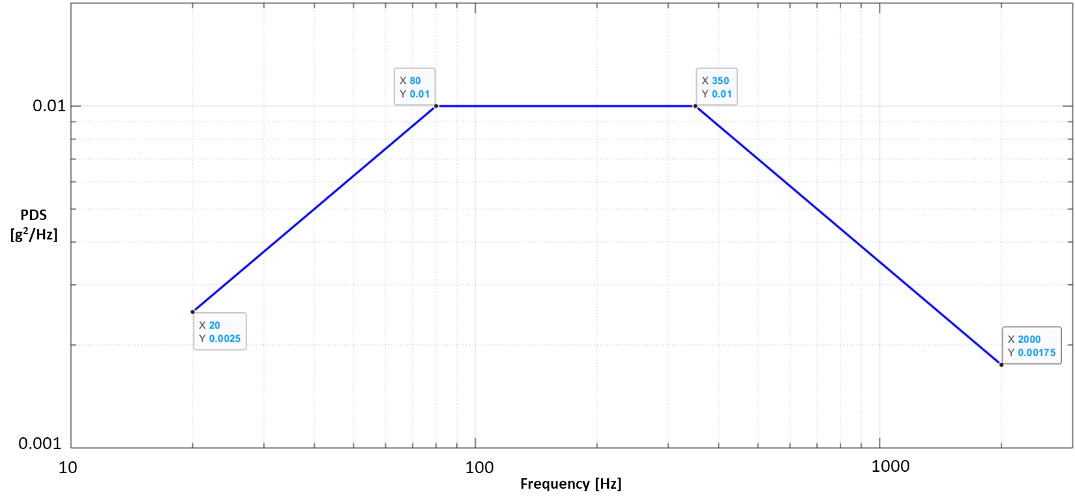
Figure ‎4-1: Random Vibration Stress Profile (ESS)

Thermal Cycling Test
8 Temperature cycles between -40°C and 60°C shall be performed.
The first cycle shall be performed to verify non-operating conditions from -54°C to +95°C.
Power shall be off during the high to low temperature excursion until stabilized at the low temperature.
For each of the operational temperature cycles the following shall be performed:
- After stabilizing in the low temperature the unit shall be powered ON and a functional test performed, and then the unit shall be left on.
- After stabilizing in the high temperature a functional test shall be performed and then the unit shall be powered off.

The chamber air temperature rate of change shall not be less than 5°C/minute.
The following graph presents one temperature cycle.
t1= Time required to thermal stabilization at low temperature and functional test.
t2= Time required to thermal stabilization at high temperature and functional test.
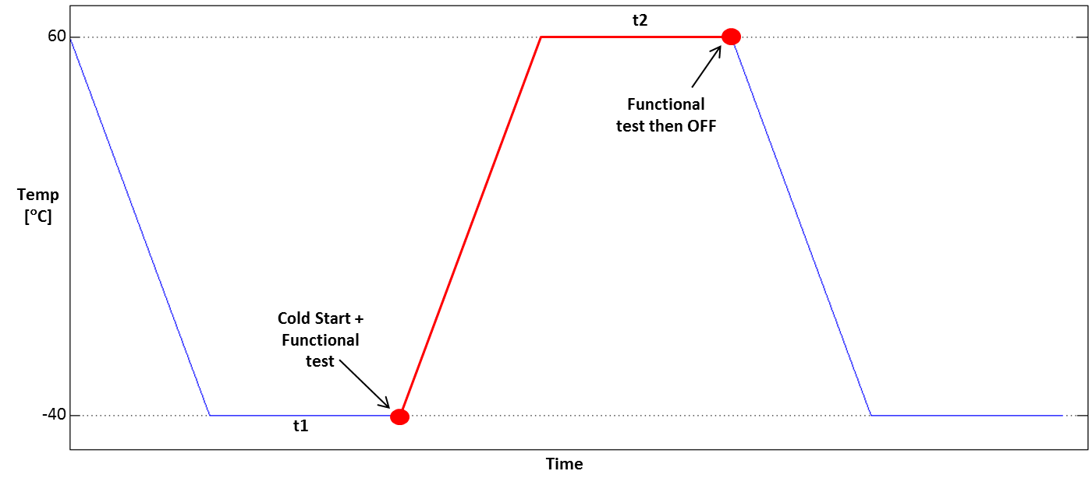
Figure ‎4-2: One Operational Temperature Cycle (ESS)

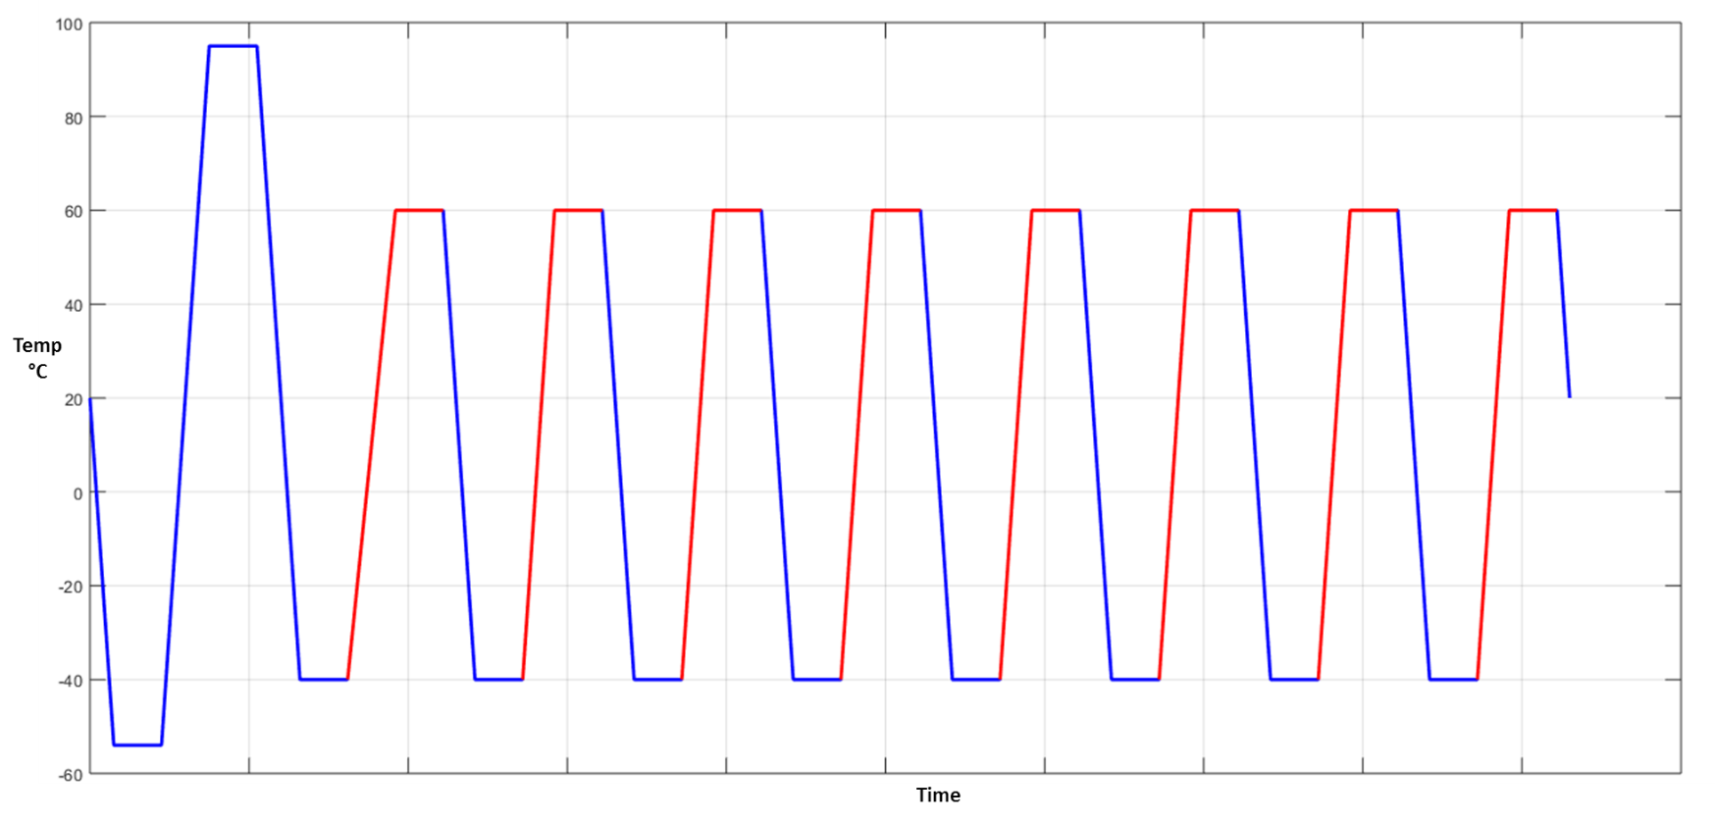
Figure ‎4-3: 1st non-op cycle + 8 operational cycles (ESS)

Requirements Traceability
This paragraph shall be generated separately using Confluence & Jira.

Preparation for Delivery
This paragraph has been tailored out.

